Blast Injuries
”True Weapons of Mass Destruction”
Written for
The European Master’s in Disaster Medicine
by
Charles Stewart MD
Associate Professor of Emergency Medicine
University of Oklahoma, Tulsa
Director of Research
Oklahoma Institute of Disaster and Emergency Medicine
Charles Stewart MD  Shusterman Center  4502 East 41st Street  Suite 2E06  Tulsa, OK 74135  Work: 918-660-2828  Fax: 918-660-3821  charles-e-stewart@ouhsc.edu | © Charles Stewart and  Associates, 2026  10909 S. Quebec Place  Tulsa, OK 74137  Voice: 918-296-3789  Cell: 918-344-4557  work@storysmith.net

Document Title: input.doc

Document Size: 0 words

Copyright to this work is retained by the Author, but the work may be freely copied for educational purposes

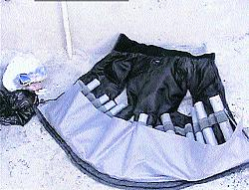
Figure 1 Suicide bomber vest
The typical vest-borne weapons of a suicide-bomber. Picture from http://www.frontlineonnet.com/fl1918/19180580.htm accessed 20 October 2003

Abbreviations used in this article

AGE – Arterial gas embolism
ANFO – Ammonium Nitrate – Fuel Oil explosive compound
ATF – Alcohol, Tobacco and Firearms
BLEVE – Boiling Liquid Expanding Vapor Explosion
CT – Computerized tomography
C4 – Composition C-4 explosive
FBI – Federal Bureau of Investigation
GI – gastrointestinal tract
HE – High order explosive
LE – Low order explosive
PETN - Pentaerythritol Tetranitrate (explosive compound)
RDX - Royal Demolition explosive
TATP – triacetone triperoxide (also called TCAP or acetone peroxide) non-nitrate high explosive
TM – tympanic membrane
TNT – tri-nitro-toluene (explosive compound)
WWI – World War I
WWII – World War II

Introduction
Prior to 1995, in the United States, most civilian emergency physicians had neither experience nor interest in the effects of explosive devices. This abruptly changed with the destruction of the Alfred P. Murrah Federal building by a truck bomb in downtown Oklahoma City in 1995 resulted in more than 750 casualties with 167 fatalities. ¹ Unfortunately, many smaller devices are exploded each year in the United States.² ³ ⁴ As we reluctantly continue to mourn the World Trade Center collapse on 9/11/2001 and events resulting from our invasion of Iraq and Afghanistan, more United States physicians have been forced to consider that they, too, may face the specter of explosions and blast injuries due to terrorism.⁵ ⁶ The July 7, 2005 London and the March 11, 2004 Madrid bombings have forced physicians in other countries to consider or reconsider their potential roles in explosions and blast injuries due to terrorism.
Bombings are clearly the most common cause of casualties in terrorist incidents.⁷ Recent terrorism has included an increasing use of suicidal/homicidal bombers that deliberately accompany the explosive device (often wearing it) to ensure that the maximum effect is derived from the explosive device.⁸ These bombers have walked or driven into buses, subways, cafes, residential areas, guard-posts, and governmental buildings. The use of these suicide devices in the United States has not yet occurred, but given the political climate, is very likely. The emergency physician is increasingly likely to see the effects of these devices. Increasingly, information resources such as the internet, terrorist training camps, and even library and television sources have made readily available the knowledge needed to construct these simple and very effective explosive devices.
The threat of delivered explosives is not confined to mail rooms or government facilities. A substantial number of explosive devices have been placed in academic facilities and in public parks during events. ⁶ ⁹
Figure 2 Historic location of United States Bomb Incidents

This article will review the current literature about blast injuries. The potential mechanisms of injury, early signs of these injuries, and the natural course of the problems caused by explosive blasts will be discussed.
Investigation about blast injury is not a new study for those interested in combat medicine. Our present knowledge of the effects of blast injury date back to the Balkan wars in 1914 when Franchino Rusca, a Swiss researcher, observed that three soldiers who had been killed by an explosion without evidence of any external injuries.¹⁰ He went on to use rabbits as an animal model and demonstrated that the cause of death was pulmonary embolism. During WWI, blast injury was thought to be a nervous system disorder and labeled “shell-shock.” (Psychological casualties were lumped together with those who had no visible injuries.)¹¹
In WWII, a noteworthy number of casualties were found among civilians in both German and British cities after bombing raids. “Blast lung” was coined for massive pulmonary hemorrhage from disruption of the alveolar architecture and formation of alveolar-venous fistulas resulting in air embolism.¹² Following WWII, nuclear weapon blast injury was intensively investigated in the USA. Only since the onset of terrorist suicide bombings have civilians been significantly concerned about the cause and treatment of blast injuries.¹¹

Critical Appraisal of the Literature
The literature of blast injuries is replete with case reports, data-mining from trauma registries and retrospective reviews. There are few meta-analyses and even fewer prospective studies. Part of this is due to the nature of the injury: sudden, random, and unpredictable. Another part is due to the dispersion in both time and space of the injuries. Although recent bombings have had wide-spread effect, they simply don’t occur in the same location enough to start a randomized study of any treatment methodology. The possible exceptions to this are in the Middle East, specifically Israel and our military in Iraq. Much of the case reports cited in this article are from researchers in Israel and the military.

Epidemiology, Etiology, Pathophysiology
An explosion is an event that occurs when a substance rapidly releases energy and produces a large volume of gaseous products. High explosive, thermobaric, and nuclear detonations all provide this change in potential energy to kinetic injury in a very short period of time. The extreme compression of molecules by this change in energy creates bands of locally high pressure, the blast wave which moves outwards from the epicenter of the blast. These blast waves travel faster than the speed of sound. Blast products – gas, particles, and debris of the container and items in proximity to the explosive (including human remains) also spread outwards, but travel much more slowly. Both the blast wave and the blast products can cause injuries as described below.
Trauma caused by explosions traditionally has been divided into the injury caused by the direct effect of the blast wave (primary injuries); the effects caused by other objects that are accelerated by the explosive wave, (secondary injuries); the effects caused by movement of the victim (tertiary injuries); and miscellaneous effects caused by the explosion or explosives.
The injury pattern following an explosion is partly random. Explosions have the potential to cause multi-system injuries involving multiple patients simultaneously. The trauma that results from an explosion depends on the combination of the size of the explosive charge, the composition and nature of the explosive, the container and surrounding or contained items, any shielding or protective barriers between the victim and the explosion, the surrounding environment, the method of delivery, and the distance between the explosion and the victim.
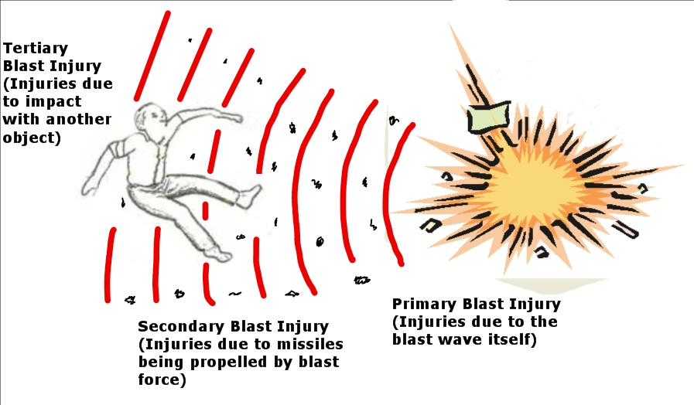
Illustration by Charles Stewart MD
Figure 3 Illustration of primary, secondary, and tertiary injury from blast

Nature of explosives
A conventional explosion is the rapid chemical conversion of a solid or liquid into gas. Thermobaric explosives (commonly called fuel-air explosives) are either gases mixed with air or finely divided particles or droplets suspended in air. Explosives are categorized as High-order Explosives or Low-order Explosives. HE and LE cause somewhat different injury patterns. Nuclear explosive effects will not be discussed in this article.

High order explosives
High explosives are chemical materials that have an extremely high reaction rate. This reaction is often called a detonation. Examples of high explosives include nitroglycerine, dynamite, C-4, picric acid, Semtex, nitroglycerin, dynamite, ammonium nitrate fuel oil mixture (ANFO), TNT, PETN and TATP (triacetone triperoxide non-nitrate high explosive).
When a high explosive detonates, it is converted almost instantaneously into a gas at very high pressure and temperature. For example the major ingredient in Composition C4 (Cyclotrimethylenetrinitramine or RDX [Royal Demolition eXplosive]) can generate an initial pressure of over 4 million pounds per square inch (4x10E⁶ PSI).¹³ These high pressure gases rapidly expand from the original volume and generate a marked pressure wave – the “blast wave” that moves outward in all directions. The result is a sudden shattering blow on the immediate surroundings.
High explosives are further categorized as primary and secondary high explosives. The primary high explosive is very sensitive, can be detonated very easily and generally is used only in primary and electrical detonators. Secondary high explosives are less sensitive, require a high energy shock wave to achieve detonation and are generally safer to handle.
The blast wave refers to an intense rise in pressure – often called “over pressure” that is created by the detonation of a high explosive.¹¹ A typical pressure wave from a high explosive explosion in air is shown in the diagram below. The pressure rises almost instantaneously in the ambient environment and then decays exponentially and may have a short period of reduced barometric pressure following the overpressure. The peak pressure and the duration of the initial positive phase of the blast wave depend on the size of the explosion and the distance from the center of the detonation. In air, the peak pressure is proportional to the cube root of the weight of explosives and inverse of the cube of the distance from the detonation. It also depends on the type of explosives used.
The blast wave transfers energy to objects or bodies in its path. The extent of damage due to the pressure wave is dependent on:
- The peak of the initial positive pressure wave
  - An overpressure of 60-80 PSI is considered potentially lethal
- The duration of the overpressure
- The medium in which it explodes.
- The distance from the incident blast wave
- Focusing due to a confined area or walls
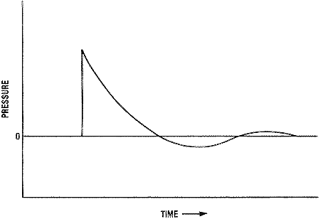
Figure 4 Pressure-time graph of blast wave
Idealized representation of pressure-time history of an explosion in air.
Courtesy Virtual Naval Hospital, Emergency War Surgery NATO handbook.
Found at http://www.vnh.org.EWSurg/Figures/Fig17.html accessed 9/12/03
As shown in the illustration, the blast wave has three components
- A single spike of increased pressure. The leading edge of the blast wave is called the blast front and is represented by this spike. The actual blast wave is only a few millimeters thick. This spike is also the most important factor in the pathology of primary blast injury.
- An exponential decay with time.
- A much longer duration negative pressure wave with pressure below initial ambient pressure.
This increase in pressure can be so abrupt that it can shatter materials – a “shock wave.” This effect is termed brisance and varies from high explosive to high explosive. When craters are formed at the site of an explosion, this shock wave has disintegrated the material close to the explosion. Because the explosive gases continue to expand outwards, the pressure wave rapidly deteriorates into an acoustic wave. Until the wave deteriorates enough to completely engulf the body simultaneously, tissue damage will depend on both the magnitude of the pressure spike and the duration of the force (represented by the area under the curve.)
A blast wave that would cause only modest injury in the open can be lethal if the victim is in a confined area or near a reflecting surface such as a solid wall or a building.¹¹ If the pressure wave is near a solid barrier, the pressure exerted at the reflecting surface may be many times that of the incident blast wave.
For a single, sharp rising blast wave caused by detonation of a high explosive, the damage to human structures is a function of the peak pressure and the duration of the initial positive phase. The greatest energy transfer occurs at points where tissue density changes. Energy transfer at a bone/soft tissue interface may (partially)amputate limbs.¹⁴
The figure below illustrates the estimated blast levels needed to cause damage in humans.
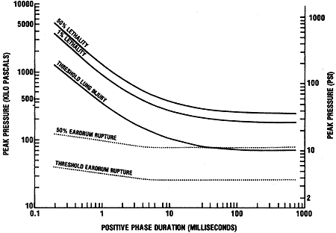
Figure 5 Estimated blast energy needed to cause damage in humans
Courtesy Virtual Naval Hospital, Emergency War Surgery NATO handbook.
Found at http://www.vnh.org.EWSurg/Figures/Fig18.html accessed 9/12/03
Blast wind refers to the rapid bulk movement of air and other gases from the explosion site. It occurs with both low order and high order explosives. Some explosives are manufactured to produce a relatively low energy blast wave but large amounts of gaseous products. These explosives produce a sustained blast wind and localized heaving with minimal blast. They are particularly useful in mining and demolition projects.

Low order explosives
Low order explosives are designed to burn and subsequently release energy relatively slowly. These explosives are often called propellants, because the most common use is to propel a projectile through a barrel. The principle military uses for low-order explosives are as propellants and in fuses. Typical improvised low-order explosives include pipe bombs, gunpowder, black powder, and petroleum based bombs such as Molotov cocktails or gasoline tankers. Since low order explosives do not form shock waves, they do not have the quality of brisance.
The process of rapid, progressive burning of a low-order explosive is called deflagration. This burning takes place so slowly that when the low-order explosive is set off in the open, the gases push aside the air with only a flame and no appreciable disturbance. If the low-order explosive is confined, the speed of the reaction is markedly increased, but does not approach that of a high order explosion. The explosion has more of a pushing effect than a shattering effect. (Blast wind without a blast wave)
The explosion from low order devices lacks the over-pressure wave and thus injuries are due to ballistics (fragmentation), blast wind from the expansion of the gases, and thermal injuries from the heat of the explosion. Obviously, it is clinically impossible to tell whether fragment wounds have occurred because the fragment was propelled by a high order explosive or a low order explosive. Likewise, if the victim is flung by blast wind into a structure, it matters little to either the patient or the clinician that the explosion occurred from detonation of a high order explosive or deflagration of a low order explosive.

Special Explosives

Thermobaric or Fuel-Air explosives
In this explosive device, a substantial quantity of fuel is vaporized and mixed with air. Fuel/air explosive represent the military application of the vapor cloud explosions and dust explosion accidents that have long plagued a variety of industries. Firefighters are familiar with the explosive effects of this device in at least three different ways:
- Dust/air mixtures in grain silos and other storage or construction areas
- Slowly escaping natural (or other flammable gases)
- BLEVE (Boiling Liquid-Expanding Vapor Explosions) ¹⁵
Since these explosive mechanisms are not uncommon in the civilian world, the emergency physician needs to know the special effects of this form of explosive. There is no question that an astute terrorist could use these mechanisms to create a massive explosion.
In the military device, mixture of the fuel with air over the target may be accomplished by a dispersal charge. After the munition is dropped or fired, the first explosive charge bursts open the container at a predetermined height and disperses the fuel in a cloud that mixes with atmospheric oxygen (the size of the cloud varies with the size of the munition). The cloud of fuel flows around objects and into structures. After the fuel and air are mixed, a second detonation provides the spark needed for ignition.
There are dramatic differences between explosions involving vapor clouds and high explosives at close distances. The shock wave from a TNT explosion is of relatively short duration, while the blast wave produced by an explosion of hydrocarbon material displays a relatively long duration. The duration of the positive phase of a shock wave is an important parameter in the response of structures to a blast. The temperature can be as high as 3,000 degrees Celsius--more than twice that generated by a conventional explosive. The blast wave can travel at approximately 10,000 feet per second.
The blast effects from vapor cloud explosions are determined not only by the amount of fuel, but more importantly by the combustion mode of the cloud. Most vapor cloud explosions are deflagrations, not detonations.¹⁶ Flame speed of a deflagration is subsonic, with flame speed increasing in restricted areas and decreasing in open areas. Significantly, a detonation is supersonic, and will proceed through most of the available flammable vapor at the detonation reaction rate. Significant overpressures can be generated by both detonations and deflagrations. Although the detonation combustion mode produces the most severe damage, fast deflagrations of the cloud can result from flame acceleration under confined and congested conditions.
Flame propagation speed has a significant influence on the blast parameters both inside and outside the source volume. High flame front speeds and resulting high blast over pressures are seen in accidental vapor cloud explosions where there is a significant amount of confinement and congestion that limits flame front expansion and increases flame turbulence. These conditions are evidently more difficult to achieve in the unconfined environment in which military fuel-air explosives are intended to operate.
Since the fuel uses up the atmospheric oxygen, asphyxia for those who are not immediately killed by the explosive device can be a real problem. Likewise, since the temperature of the burning fuel is greater than that of conventional explosives, burns must be considered.

Explosively formed projectiles and shaped charges
Charles Edward Munroe was the inventor of "The Monroe Effect" in explosives in 1885. He noted that a high explosive with a cavity facing a target left an indentation. The earliest known reference to the effect appears to be 1792, and there is some indication that mining engineers may have exploited the phenomenon over 150 years ago. A typical shaped charge consists of a solid cylinder of explosive with a conical hollow on one end, lined with a dense ductile metal such as copper. When detonated from the other end, the force of the explosive detonation wave is great enough to project the copper into a thin, effectively liquid, stretching jet having a tip speed of up to 12 km/s. The enormous pressures generated cause the target material to yield and flow plastically. A common misconception is that the penetration is a result of melting, but both jet and target usually remain in a solid state.
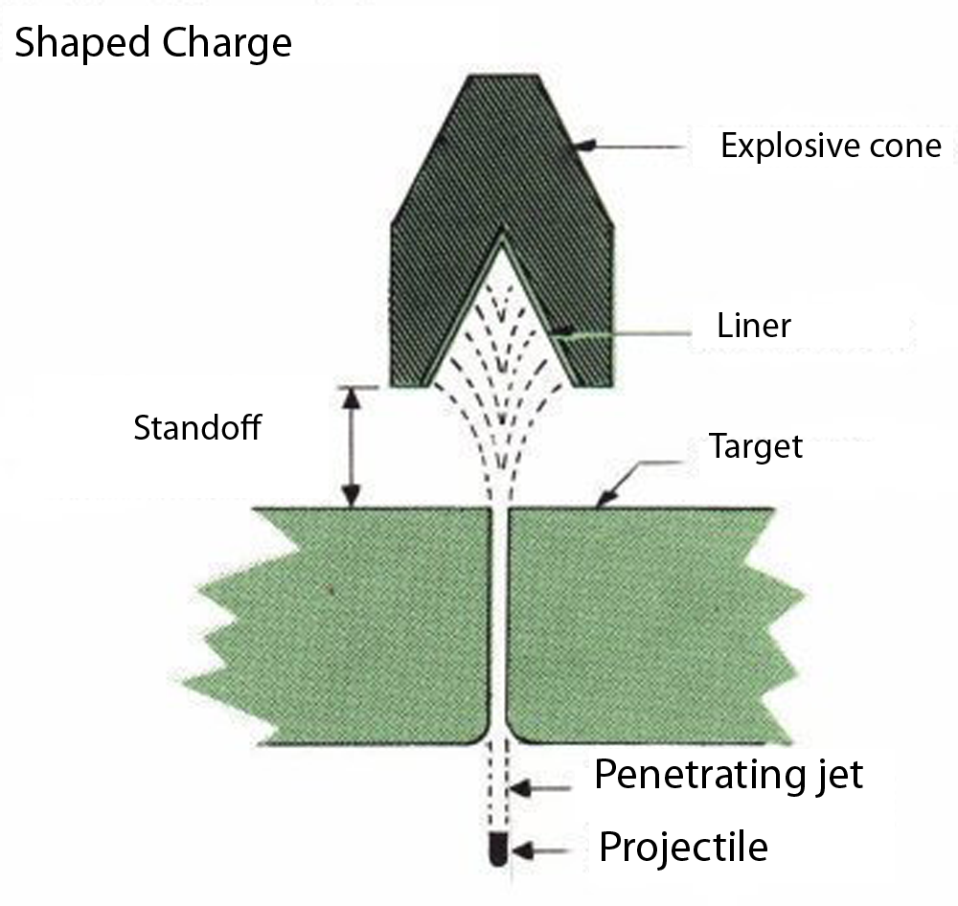
Figure 6 Shaped Charge
Explosively formed projectiles (EFPs) are related to shaped charges but form a fragment rather than a jet. These sophisticated devices have been used in Iraq against Allied forces. They routinely defeat armor and can cause significant injuries.
A computer-designed dish-shaped metal liner is placed in front of an explosive charge. These wide angle cones and other liner shapes such as plates or dishes do not jet, but give instead an explosively formed projectile or EFP, as illustrated in Figure 3. When the explosive is detonated, the shockwave deforms the liner in a preset way to create a symmetric projectile travelling at very high speeds. Varying the liner shape and explosive confinement changes the shape and velocity.
Figure 7 Explosively formed projectile
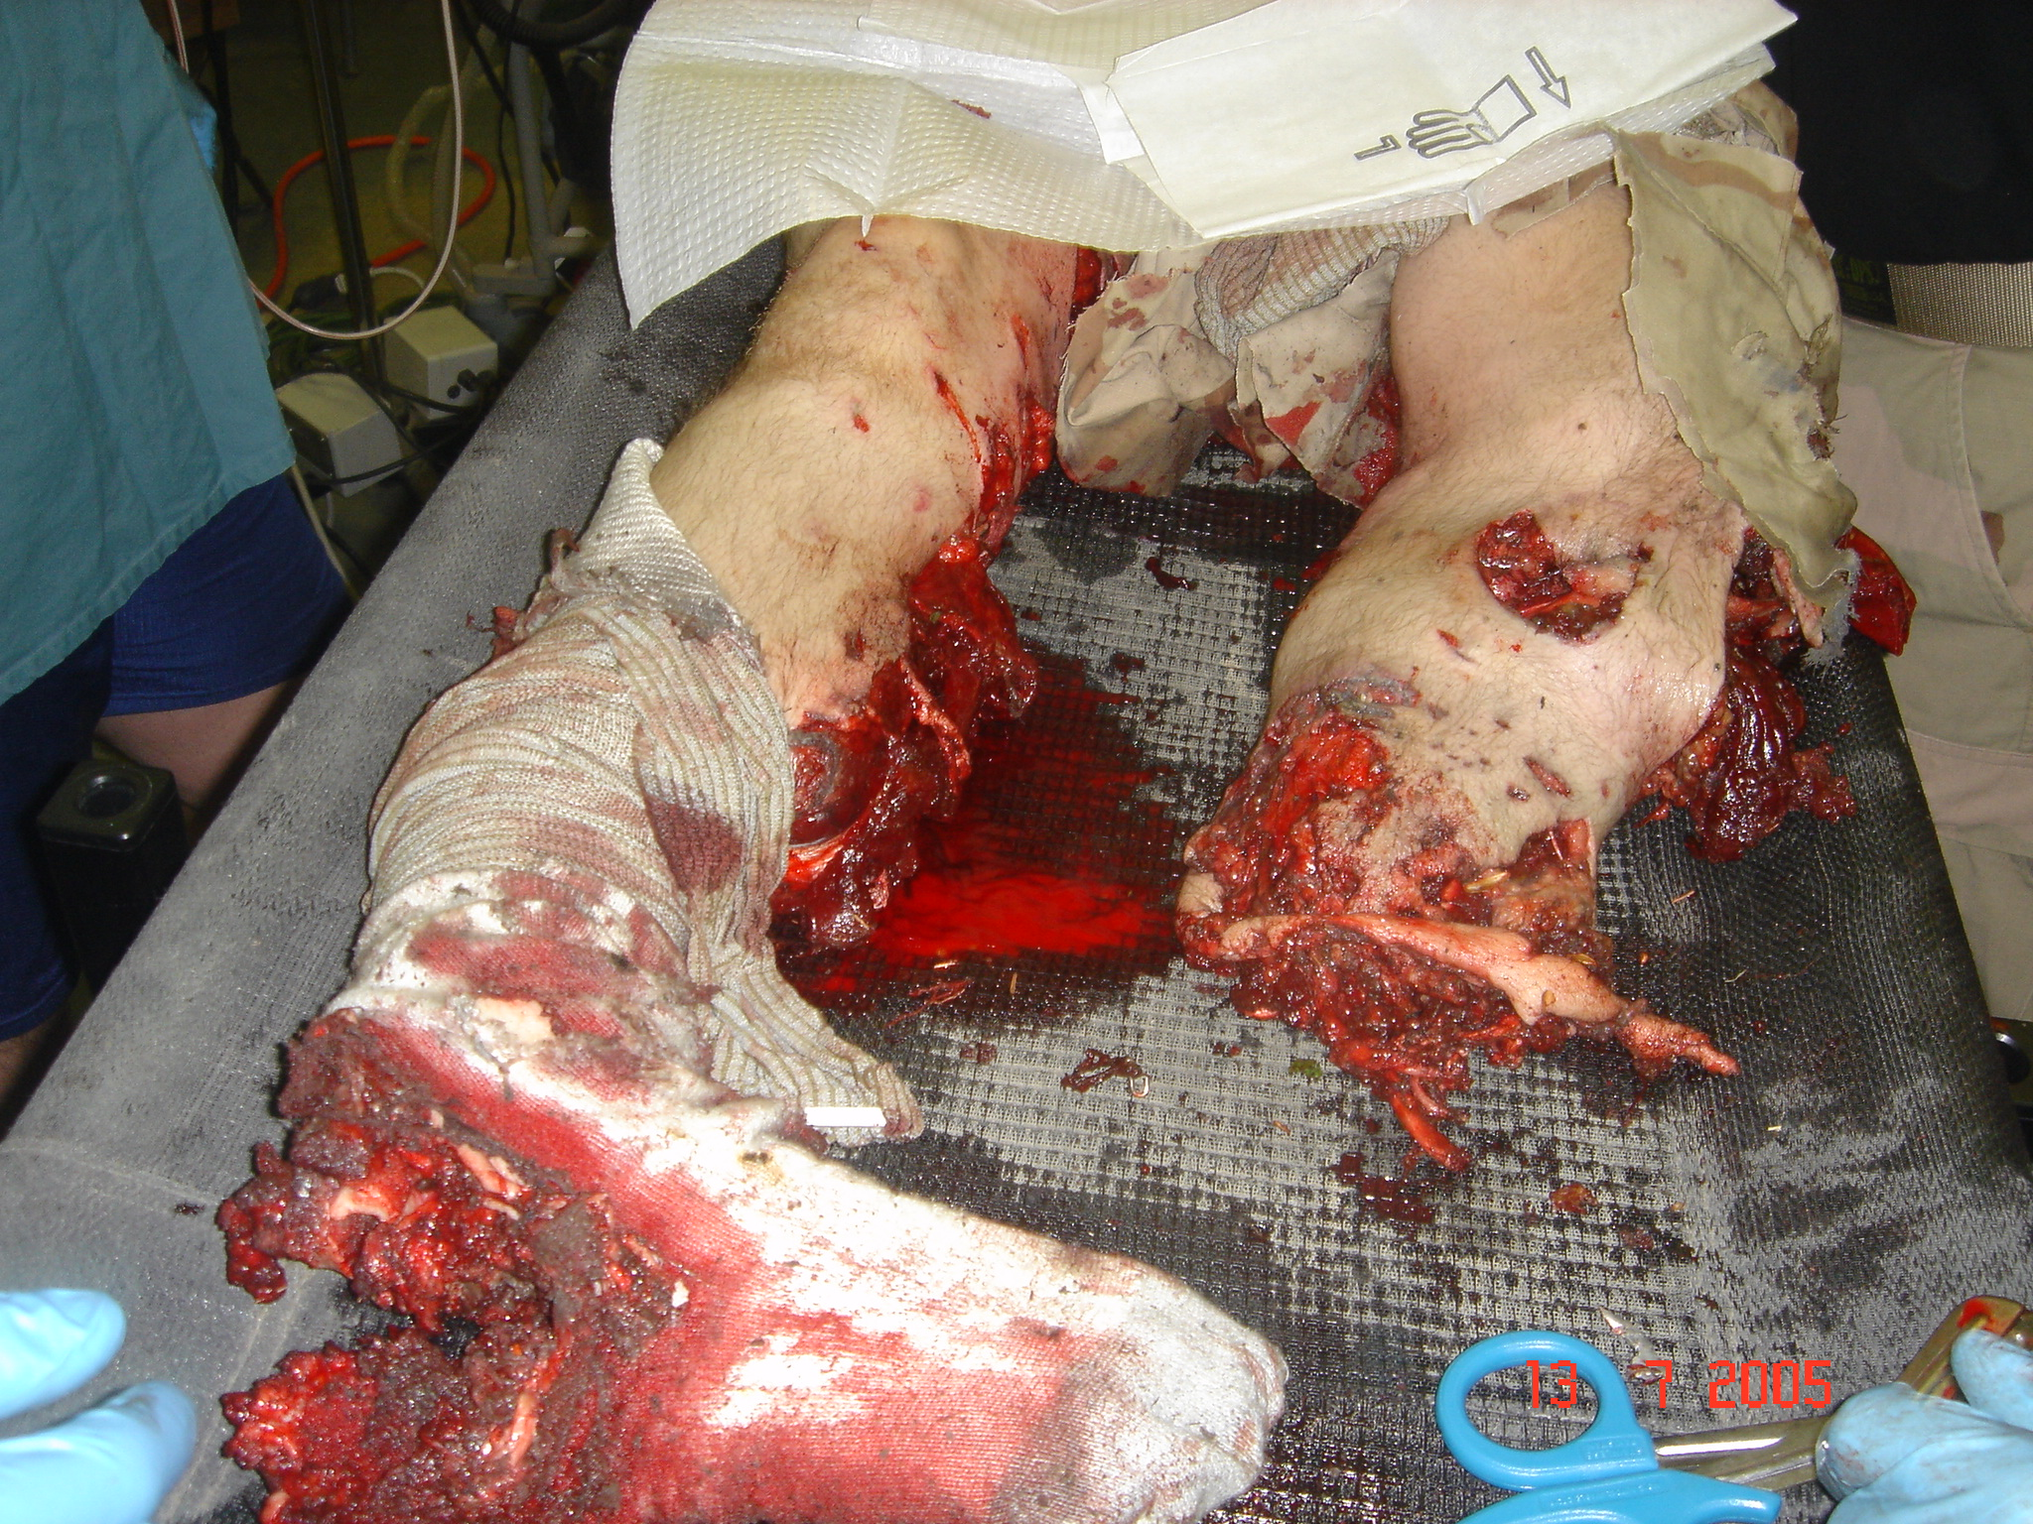
Results of explosively formed projectile impact on human being
Photograph by MAJ Paul Morton, Used with permission.

Source of explosive
Explosive devices may also be characterized based on their source. The bureau of Alcohol, Tobacco, and Firearms categorizes explosives into “manufactured” and “improvised.” A “manufactured” explosive implies a standard, mass produced, and quality tested weapon. “Improvised” describes the use of alternative materials, weapons produced in small quantities, or a device that is used outside of its intended purpose. Improvised explosive devices may be professional in appearance and operation may quite lethal if designed by someone with training in explosives. (Note that by this definition, any experimental explosive device is an “improvised” device, since it is not set to standards, mass produced, and quality tested.) This rather unwieldy definition includes all experimental military devices produced by professional arms manufacturers.)
Improvised explosive devices (and many military munitions) can be triggered in a variety of ways, including electronic transmitters and switches, tilt switches, thermal switches and various types of motion detectors. Improvised weapons vary in quality of the explosive used from use of commercial explosives, TNT, Semtex, C-4, ammonia based fertilizer and fuel oil (used widely as an industrial explosive) to a match-filled pipe bomb. High quality improvised devices may resemble military weapons in effect and appearance. The variety of initiation methods, explosive filling, and fabrication techniques creates a threat that can be quite daunting to the professional explosive ordinance disposal crew.
Recent improvised devices have been manufactured with non-nitrogen explosives (TATP) in order to defeat explosive sniffing devices and dogs. These non-nitrogen explosives are often quite unstable and may spontaneously detonate. It also means that no matter how innocuous the appearance of an improvised device, the amateur should not touch the device.

Medium in which the explosion occurs
Another important concept that defines blast injury patterns is the medium in which the blast occurs. An underwater blast wave causes far more damage because water is essentially incompressible.¹¹ ¹⁷ A wave resulting from an underwater blast travels farther and moves faster than a wave from a similar explosion in the air. Blast injuries in water occur at greater distances and may be much more severe.¹⁸ ¹⁹ Personnel treading water are at higher risk for abdominal than thoracic injury from an underwater explosion. Fully submerged victims are at equal risk of combined thoracic and abdominal blast injuries but the blast injury occurs at three times the distance from the underwater explosion.²⁰
Another characteristic of blast waves is that they are indeed waves. The injury patterns they produce are not only related to the medium through which they travel, but the position of the victim’s body in relation to reflecting or deflecting objects that the wave strikes. For example, explosions near or within hard solid surfaces become magnified 2-9 times as the shock wave is reflected.²¹ In fact, victims located between the blast and a building generally suffer 2-3 times the degree of injury that an individual in an open environment would receive.²²
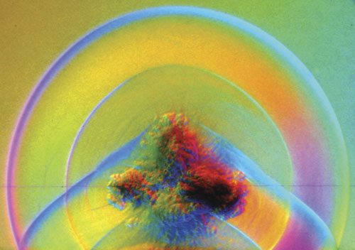
Figure 8 Blast waves from explosion
Courtesy Harald Kleine

Body armor provides a false sense of security during an explosive detonation. The body armor does protect the victim from shrapnel and to a lesser extent, objects picked up and flung by the blast wave, but it also provides a reflecting surface that can concentrate the power of the explosion as the blast wave reflects off of the armor front and back.²³⁻²⁶ (Since the bulk of injuries from an explosive device are from secondary objects flung by the blast wave, the advantages of body armor outweigh the risk of enhancement of the blast wave.) The medical provider should not assume that body armor will protect the victim from an explosion-related injury.²⁶

Pathophysiology
Blast injury has an overall lethality of about 7.8% in open air. This jumps to 49% when the blast occurs in confined spaces. 70% of victims will sustain minor soft tissue injuries.²² Traumatic amputations will occur in about 11%. Traumatic amputations serve as a marker of severe multisystem trauma and subsequent high mortality.¹⁴ The World Trade Center was unusual as most victims had either few injuries or died as the building crashed down on them.

Primary blast injury
Primary blast injuries are caused only by high explosives and are due to the direct effects of the blast wave on the human body. (Since low-order explosives do not form a supersonic blast wave, they cannot cause primary blast injury. This difference is the sole apparent clinical difference between wounds caused by a low order explosive and a high order explosive.)
The overall incidence of primary blast injury is about 20%. (The victims of primary blast injury almost always have other types of injury, such as penetrating wounds from flying debris or blunt trauma from impact on immovable objects).²⁷
The extent of damage from the explosion depends upon:
- The peak of the initial positive wave
  - This is directly related to the magnitude of the explosion and to the proximity of the victim to the explosion.
- The duration of the overpressure
- The medium in which it explodes
- The distance from the incident blast wave
- The nature and number of reflections in confined areas and with reflecting walls
Overpressure in PSI | Effect
1-2 | Frame house destroyed
3-5 | Typical commercial construction destroyed
5 | Tympanic membrane rupture
15 | Tympanic membrane rupture in 50% of patients
30-40 | Possible lung injury
40 | Reinforced concrete construction destroyed
75 | Lung injury in 50% of patients
100 | Possible fatal injuries
200 | Death most likely
Table adapted from: Rice DC, Heck JJ. Terrorist Bombings: Ballistics, patterns of blast injury and tactical emergency care.²¹
Table 1 Blast injury pressure vs. injury

Mechanism of blast injury
In World War II, blast overpressures were thought to gain access to internal organs through natural orifices.²⁸ This has since been proven inaccurate. Other more recent theories that have been proposed include implosion of gas containing structures, inertial effects on tissues of different densities, and spalling at water-gas interfaces.
The most likely mechanism of primary blast injury that fits current modeling techniques is the irreversible work effect related to the differences in tissue tensile strength and speed of the blast wave through the different tissues. This may be the most important effect of the blast injury and is currently thought to be the major cause of primary blast injuries.²³ The onset of damage occurs when the blast wave compresses the tissues. The resulting forces exceed the tensile strength of the material and cause shearing of vascular beds, pulmonary contusions, and gastrointestinal hemorrhages as the tissues are compressed and expanded. ^{24,29}
The illustration often used is of an aluminum can that is dented slightly and pushed back into shape. When the can is stressed beyond its tensile strength, it can no longer be restored to original shape.³⁰
Some combination of stress and shear waves is likely in all non-penetrating blast trauma. Stress that exceeds tissue tensile strength probably predominates when blast surface loading exceeds velocities of 80-90 m/sec.²³
Primary blast injury is common in the ear, the respiratory tract, and the gastrointestinal tract. Of the three organ systems, the ear is the most easily damaged.

Ear damage
Of the three organ systems, the ear is the most easily damaged, but it is also the easiest to protect. The structures of the ear are designed to collect and magnify sounds, so that the tympanic membrane will move with the sounds. Unfortunately they also collect and magnify pressure waves. At a pressure of about 35 kilopascals (5 PSI), the human eardrum may rupture. With an overpressure of 100 kPa (14 PSI) almost all eardrums will be ruptured. The eardrum most frequently ruptures into the inferior pars tensa. At lesser pressures, the overpressure may cause hemorrhage into the drum without a rupture. With extremely high pressures, the drum may be destroyed and the ossicles dislocated or fractured.³¹
Rupture of the eardrum will cause pain, hearing loss, and may cause tinnitus. Eardrum perforations, hearing loss and dizziness may interfere with daily activities and may have a telling effect on the individual’s quality of life.³¹
Physical examination may reveal blood in the external canal. Examination of the tympanic membrane with an otoscope may show evidence of the perforation.
It is often held as gospel that rupture of the tympanic membrane is a marker for serious gastrointestinal or pulmonary injury. If the patient has ear protection, this may not be the case. Likewise, if the patient is in the water with head out of the water, the tympanic membranes may not be exposed to an underwater blast wave. Even in those exposed to simple blast injury, isolated eardrum rupture does not appear to be a good marker of concealed pulmonary blast injury or poor prognosis.³²
Auditory barotrauma is quite common in blast injuries. In the Oklahoma City bombing, the incidence of auditory injury was 35%.³³ ¹ This does not count those patients with partial, temporary hearing losses or those who complain of tinnitus for an extended period of time.³¹

Pulmonary damage
The lungs are particularly susceptible to damage due to the extensive air/lung tissue interfaces. Blast lung is a direct consequence of the supersonic pressure wave generated by a high explosive.³⁴ It is the most common fatal injury caused by the primary blast injury among the initial survivors of the explosion. These lung injuries may not be apparent externally or immediately, but may lead to death if not diagnosed and treated promptly. An overpressure of about 40 PSI will cause lung injuries.
Pulmonary blast effects in survivors have bed described as rare in the British literature, but are observed more often in the Israeli experience with enclosed explosions that occur on a bus.^{35,36}

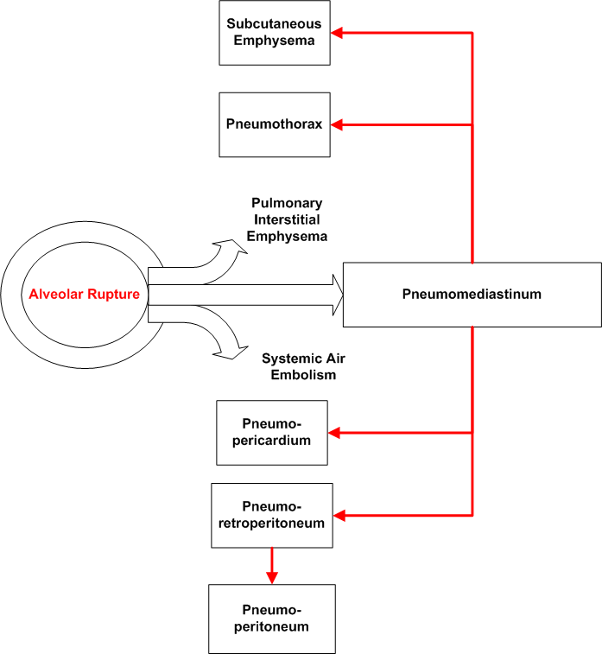
Figure 9 Illustration of pulmonary injury mechanisms
Author’s illustration.
Damage to the lungs can include pulmonary contusions, with or without a laceration, and/or pulmonary barotrauma such as pneumothorax, pulmonary interstitial emphysema, pneumomediastinum, or subcutaneous emphysema. The most common lung injury associated with a blast wave is a pulmonary contusion. ³⁷ ³⁸ This may take the form of micro-hemorrhages with perivascular/peribronchial disruption. It appears to be more common on the side closest to the explosion, but this may be influenced by the geometry of the surrounding area and reflected energy.³⁹ ³⁸ ³⁷ The alveolar wall may be torn causing a blood-filled emphysematous change to the lung. Pulmonary contusions may develop with or without a pulmonary laceration.
Assume that if a patient is wheezing after a blast injury, that this wheezing is due to a pulmonary contusion. Other causes of wheezing may be pulmonary edema from myocardial contusion or infarction, or exacerbation of underlying disorders such as asthma or COPD.
Pulmonary contusions impair gas exchange at the alveolar level. The changes seen on microscopic examination closely resemble the pulmonary contusions sent in non-penetrating blunt chest trauma. The histologic appearance of lung damage by blast overpressure is dominated by hemorrhage into the alveolar spaces. The degree of respiratory insufficiency depends on the magnitude of hemorrhage into the lung.
Parallel thoracic ecchymoses, once thought to be along the ribs, may be seen with larger blast loads.³⁰ ³⁸ These ecchymoses parallel the intercostal spaces. Rib fractures may occur due to blast injury, but are much more likely to be due to secondary or tertiary blast injury mechanisms, at least in survivors. ⁴⁰ ³⁷
The patient may have minimal or no symptoms initially. The patient may also complain of chest pain or respiratory distress. Signs of blast lung are usually present at the time of the initial evaluation, but have been reported as late as 48 hours after the explosion occurs.
The occurrence of late pulmonary symptoms in primary lung blast injury has recently been question by Pizov, et al, who described 15 patients with primary lung blast injury.⁴⁰ All of the patients required intubation and ventilation either at the scene of the explosion or on admission to the emergency department. No patient in their series developed blast lung that did not require ventilatory support within the first 6 hours after the injury. It should be noted that all of the patients in this series were victims of blast injury within the enclosed confines of a “bus bombing.” As noted earlier, blast pressures within enclosed areas are often much higher.
The overpressure may cause pulmonary barotrauma including pneumothorax or pneumomediastinum. (See Figure 9 Illustration of pulmonary injury mechanisms.) The patient may develop pulmonary interstitial emphysema, subcutaneous emphysema, and systemic air embolism, with larger blast loads.³⁰ ²⁹ ²⁴ ⁴¹ Significant bronchopleural fistulae may lead to air embolism. Air emboli may present in a variety of ways, including shock, myocardial infarction, spinal infarction, or cerebrovascular accident. (See table 2 for correlation of severity and injury frequency.)
Blast lung is clinically characterized by the triad of dyspnea, bradycardia, and hypotension. The clinician should suspect blast lung in any victim who presents with dyspnea, cough, hemoptysis, or chest pain following blast exposure.
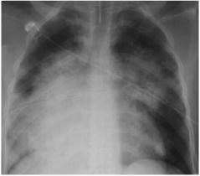
Figure 10 - Radiograph of blast lung
Blast lung picture from Surgical Clinics of North America, 1999.
Permission applied for.
A simple frontal chest x-ray is diagnostic for most cases of pulmonary barotrauma from blast. Blast lung produces a characteristic “butterfly” pattern on chest x-ray. The pulmonary injuries found may range from scattered isolated petechiae to confluent pulmonary hemorrhages. The radiographic evidence of pulmonary injury usually begins within hours of the explosion and begins to resolve within one week.⁴²

Status of injury | Findings | Therapy
Insignificant | None | None
Mild | SpO2 > 75% on room air  May have pneumothorax  Rare bronchopleural fistulae | Low PEEP (<5cm H₂O) no positive pressure ventilation  Unlikely to need PPV
Moderate | SPO2 > 90% on 100% supplemental oxygen  Pneumothorax common  Bronchopleural fistulae possible | PEEP (5-10 cm H₂O) and positive pressure ventilation
Severe | SPO2 < 90% on 100% supplemental oxygen  Pneumothorax almost universal  Bronchopleural fistulae common | PEEP (> 10 cm H₂O) and pressure controlled ventilation
Adapted from Pizov R. Oppenheim-Eden A, et al. Blast lung injury from an explosion on a civilian bus. Chest 1999;115:165-172 and Wightman J. Blast injuries: Recognition and management. Found at http://www.brooksidepress.org/Products/OperationalMedicine/DATA/operationalmed/MilitaryMedicine/Blast%20Injuries/BlastInjuriesRecognitionandManagement.htm Accessed 1/5/2006.
Table 2 - Blast injury severity

Gastrointestinal damage
Gastrointestinal injuries may not be apparent externally. They have a great potential to cause death and may be much more difficult to protect against.
GI injuries were once thought appear to occur with the same frequency as lung injury. A recent large Israeli case series found that abdominal injuries were seen only with massive trauma.³⁵ This series had all of the patients in open air. The patient may have a greater risk for gastrointestinal injury when exposed to an underwater blast.¹⁸
The GI injury of primary blast injury is inconsistent in presentation. It may consist of hemorrhage beneath the visceral peritoneum or may extend into the mesentery, colon, and cecum.³⁸ ³⁹ Contused bowel may necrose and perforate several days after the initial trauma. The perforated bowel may be immediately apparent, or may perforate only after a delay of up to 48 hours.⁴³ ⁴⁴
Pneumoperitoneum is a known, but relatively rare complication of GI barotrauma.⁴⁵ This complication has a wide differential diagnosis ranging from perforated viscus to simple dissection of air through the retroperitoneum.
The colon is the most common site of both hemorrhage and perforation.³⁸ ¹⁸ This is thought to be because the colon has the most bowel gas accumulation in the GI tract.
Solid organ laceration and testicular rupture are also seen due to primary blast injury, but are less frequent and often associated with large blast forces.⁴⁶ The most common lesions reported were subcapsular hematomas in the liver, spleen, and kidneys.⁴² Mesenteric, scrotal and retroperitoneal hemorrhages have been reported. ³⁸
These lesions can lead to the clinical signs of absent bowel sounds, bright red blood per rectum, guarding and rebound tenderness. The clinical symptoms can include abdominal pain, nausea, vomiting, diarrhea, and tenesmus. Blast injury to the gastrointestinal tract should be suspected in anyone exposed to an explosion that has abdominal pain, nausea, vomiting, hematemesis, rectal pain, testicular pain, unexplained hypovolemia, or any finding compatible with an acute abdomen.
The clinician should be aware that the abundant high-velocity fragments associated with recent suicide bombs may also cause intraabdominal injuries. These injuries can certainly include penetrating bowel injuries.⁴⁷ Initial symptoms of penetration are the same as outlined above.

Brain injury
Primary blast injury can cause concussion or traumatic brain injury, although this finding is difficult to tell from the concussion due to impact with another object. The clinician should be quick to consider CT or MRI in these patients.

Cardiac Injury
Although the heart is well protected and not subject to the air/fluid shear of primary blast injury, myocardial contusion lead to either arrhythmia or hypotension. ²³

Secondary blast injury
Secondary blast injury is caused by the bomb fragments and other debris that is propelled by intense energy release of the explosion. As the distance from the blast epicenter increases, the effect of blast reduces and the effect of fragments and debris propelled by the explosive becomes more important. Conventional military explosives may create multiple fragments with initial velocities of up to 2,500 m/sec (8202 feet per second).⁴⁸ (In contrast, the very fast moving M-16 round has a muzzle velocity of 853 meters (2,800 feet) per second.)⁴⁹
These flying projectiles can produce both penetrating and blunt trauma, depending on the size of the projectile and the speed at which they travel. With these velocities, the victim does not have to be in close proximity to the explosion. Individuals far from the scene of an explosion can be struck and injured by this debris. After the 1998 terrorist bombing of the US Embassy in Nairobi, flying glass wounded victims up to 2 kilometers away.²³ In U. S. Air Force personnel in the Khobar Towers in 1996, 88% of patients were injured by flying glass.⁵⁰ (The reason for the “stand-off distances” noted in the accompanying tables is to decrease to acceptable limits the number of injuries that occur from flying debris when the bomb explodes.) The farther away the explosion occurs, the less serious the injury.
Terrorist devices often have additional objects such as nails, nuts, and bolts added to the explosive mixture in order to increase the effects of secondary blast injury. These fragments are of high mass and kinetic energy and the damage that they inflict at close range is considerable. Military devices such as shells and grenades may be designed in such a way as to increase the number of fragments (shrapnel) flung by the explosion.
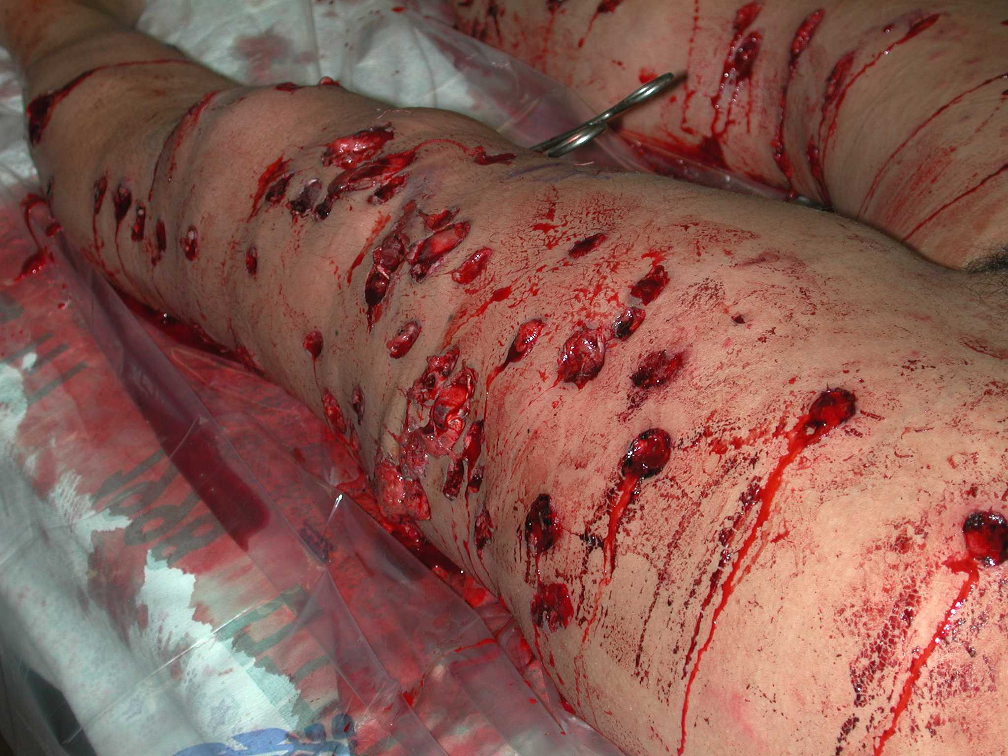
Figure 11 - Multiple fragment wounds from blast injury
Fragment injuries from a suicide/homicide bomber in Israel. This device had large metallic nuts contained within the explosive vest, in order to increase casualties.
Photo courtesy of Prof Zvi Gimmon, M.D.

Secondary blast injury is much more common than primary blast injuries. Indeed, secondary blast injury is the most common cause of death in blast victims. The penetrating injuries occur most often in the exposed areas such as the head, neck, and extremities. Thoracic and intraabdominal injuries may occur when fragments penetrate.⁴⁷
Glass causes many of the secondary blast injuries (up to 50% of all blast injuries). Victims that are peppered with glass are often difficult to distinguish from victims that are peppered with glass and have penetrating injuries.⁵¹
Secondary blast injuries may not be initially obvious. A seemingly small abrasion or wound may mask the entrance wound for a substantial fragment.
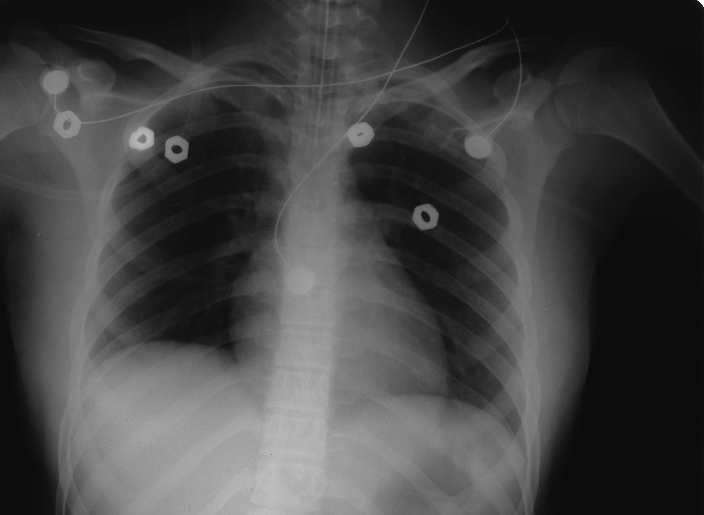
Figure 12 - Radiograph of chest injury from bolts as missiles.
Chest X-ray showing bolts used as missiles in a suicide/homicide bomb.
Photo courtesy of Prof Zvi Gimmon, M.D.
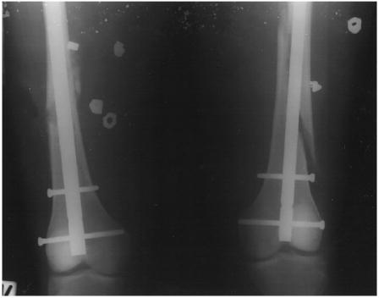
Figure 13 - Blast injury due to bolts as missiles
Multiple nuts in both thighs. The force imparted was sufficient to fracture both femurs, which have been repaired. Surg Clin NA (same as above)
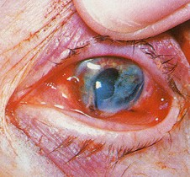
Figure 14 - Blast injury of eye
Rupture of eye with prolapsing iris due to explosion and direct trauma
Photo from Richmondeye. http://www.richmondeye.com/fireworks.htm permission applied for.
Up to 10% of blast survivors will have significant eye injuries.⁵² These injuries may be perforations from high-velocity projectiles. Glass is notorious for causing these ocular injuries. Window fragments often don’t kill, but can cause blindness and ruptured globes. At the speed that explosively-propelled fragments of glass travel, there is no time for the blink reflex to operate. These injuries can occur with minimal initial discomfort and present for case days after the event. Symptoms include eye pain and irritation, foreign body sensation, alterations of vision, periorbital swelling or periocular contusions. Signs can include loss of vision, decreased visual acuity, globe perforation or rupture, lid lacerations, and subconjunctival hemorrhage around the point of entry.

Tertiary blast injuries
Tertiary blast injuries are caused when the victim’s body is propelled into another object by the blast winds.⁵³ ³⁰ Tertiary effects result from the bulk flow of gas away from the explosion. Blast winds can generate a body acceleration of over 15g’s. They most often occur when the victim is quite close to the explosion.
This displacement of the victim can take place relatively far from the point of detonation if the victim is unfortunately positioned in the path where gases must take to vent from a structure, such as a doorway, window, or hatch. Likewise, if the patient is in an alley, magnification of the blast wind may occur due to the configuration of the buildings.
It is the deceleration caused by impact into a rigid structure that causes the majority of injuries. A person who is flung into a fortified immovable object with a velocity greater than 26 f/second will have a mortality rate of about 50%.⁵⁴ The most common injuries are fractures and closed head injuries. Isolated body parts may be broken, dislocated, or even amputated. Injuries from this mechanism also depend on what the victim hits in the environment. They can range from simple contusions to impalement. Victims may tumble along the ground sustaining abrasions, contusions, and “road-rash.”

Miscellaneous blast effects (Quaternary blast injuries)
This category includes burns from fire or radiation, crush injury associated with structural collapse, poisoning from carbon monoxide or other toxic products of the explosion, and inhalation of dust or chemicals from the explosion.
The unprotected human body can survive a blast with a peak overpressure of 30 PSI, but buildings and other structures collapse with stress of only a few pounds per square inch. This means that persons can survive the effects of the blast, only to be injured by collapsing buildings.
The blast may be a vector for chemical warfare agents and biological warfare agents. The effects of these agents on the body may well overshadow any part of the explosive energy.
Patients who have been exposed to a blast in an enclosed area should have carboxyhemoglobin levels obtained. Inhalation of irritant gases or dusts may also trigger wheezing in these patients.

Differential Diagnosis

Pre-hospital Care
The job of the prehospital provider faced with a major explosion will be difficult. The emergency services provider needs to ensure appropriate on-scene management, including triage, transportation to medical care, and appropriate distribution to hospitals with both facilities and skills to care for the victims. There may be additional problems due to unsafe or collapsed buildings, the dangers of further explosions, and civilian panic.⁷
The predominant injury found after most explosions will be penetrating and blunt trauma. An explosion that occurs in a confined space (including vehicles, mines, buildings, and subways) is associated with greater morbidity and mortality. If the structure collapses, this markedly increases the mortality associated with the event (assuming that there are people in the structure.)
The early presentation of victims can be deceiving because the initial manifestations of significant blast injury can be subtle. Blast lung injury is the most common fatal injury among initial survivors of the blast.
Field Medical Care
- Initial care is similar to regular trauma care
- Identify and correct ABC’s of trauma care as rapidly as possible given constraints of multiple casualties.
- Identify and correct life-threatening external hemorrhage at once. This is the most common cause of preventable death on the battlefield.
- Ear and GI injury do not need special care in the field.
- Rapid evacuation increases the chance of survival.
- Do not do definitive care in triage
- Do not do extensive resuscitation in the field.
  - As noted below, CPR at the scene of a mass casualty is not indicated
- Early (field) normal vital signs may be an inaccurate guide to the severity of injury in patients with blast lung, barotrauma, and or/hemorrhage and rupture of gas-filled hollow organs.
If the blast casualty is ambulatory, it is critical to minimize physical activity. Exertion after blast injury can markedly increase the severity of the primary blast injury. This was seen in WWII when some blast casualties appeared well but died after vigorous activity.⁵⁵
The EMS provider should be wary of secondary (and rarely tertiary) devices and explosions. Foreign experience has shown that terrorists often will set a second device timed to explode some 30 to 100 minutes after the first device has detonated.⁵⁶ ⁵⁷ This second device is designed to damage EMS, fire, and police personnel who may be at the scene. This second device may often be larger than the first. In some cases, the perpetrator of the explosion may be watching over the area of the explosion and either remotely detonate the second explosive, or employ high-powered rifle fire to injure or kill responders.
Remember to check all victims for weapons, booby traps, and explosives. It is quite common for a bomber to become a victim of his own device.
Fatal injuries can occur due to blast effects involving the head, chest, and abdomen and are often seen in victims who are close to the detonation.⁵⁸ Indeed, in some of these victims close to the site of the blast, parts of the victim (or perpetrator) can become missiles that kill or wound other victims.⁵⁹ Immediate death may occur from massive pulmonary bleeding with rapid suffocation, despite good care. The patient may develop a massive air embolism. The patient may sustain a significant brain injury. The patient may suffer a traumatic amputation and exsanguinate before help arrives. Finally, the patient may have a crush injury or impalement injury that causes rapid death before extrication can occur.
The field physician or paramedic should consider a patient dead in the field when there is:
- An amputated body part without signs of life.
- No effective respirations
- No palpable pulse
- Dilated pupils
- Immediate severe respiratory insufficiency that is caused by a blast effect has far less chance of survival.
CPR at the scene is never indicated. There will be too many injured, not enough medical providers, and no significant chance of successful resuscitation in this blunt trauma patient.
Finally, evacuation from the blast site to medical care can be problematic. The barotrauma that results from primary blast injury can be exacerbated by evacuation. Pneumothorax and arterial gas emboli will enlarge with ascent. Regardless of the altitude and distance of the flight, casualties with field evidence of pneumothorax must have a chest tube placed. Evacuation aircraft should fly at the lowest possible altitude. Evacuation by long-distance, high-altitude flights should be avoided. Evacuation aircraft should be pressurized to at least 8000 feet (preferably 5000 feet).
If the victim has marginal oxygenation (PO₂ < 60 mm Hg), the clinician should recognize that oxygenation will worsen with ascent in an aircraft (with the increase in altitude and subsequent decreased barometric pressure).

Emergency Department Evaluation
Expect that the most severely injured patients will arrive after the less injured. The less injured often skip EMS and proceed directly to the closest hospitals.¹ For a rough prediction of the “first wave” of casualties, double the first hour’s casualty count.
Remember that a secondary device may be employed that can cause substantial additional casualties including EMS, fire, police, and media.
Most casualties within the injury radius of a conventional explosive detonation or deflagration will have common penetrating, blunt, and burn injuries that are managed no differently than similar non-blast trauma.⁶⁰ Much of this trauma is soft-tissue, orthopedic, or head injuries.⁶¹ ³³ ⁶² The detailed management of these injuries is beyond the scope of this article.
The first and most important step of management is assessment of life support needs and ensuring that the patient has an adequate airway, appropriate ventilation, and adequate circulation. Identify and correct life-threatening external hemorrhage at once. Arrhythmias (particularly bradycardia), hypotension, and apnea are frequently observed after blast injury to the thorax and have been associated with primary blast wave effects on the myocardium and vagal stimulation.^{12,63}
A thorough physical examination should be then performed. The emergency physician should look for sentinel signs of potentially significant blast exposure. (See sidebar table.) Unfortunately, when the health care provider is faced with dramatic injuries such as amputations, fragment injuries, and multiple critically ill patients, it is altogether too easy to miss the subtle signs of blast injury. If the clinician does not consider the possibility of primary blast injury, it may further complicate the patient’s care.

Important historical questions
Can you hear me? Do you have ear pain? Tympanic membrane rupture and temporary hearing loss is common in blast injury, but should not be life threatening. (Unless the casualty cannot hear life-saving commands or communications!)
Are you short of breath? Do you get short of breath with walking? A pulmonary contusion will inhibit oxygen diffusion and will require more effort to inhale. Pneumothorax and hemothorax can decrease the volume of inspired air with resultant subjective dyspnea. Shock from other causes can give the sensation of dyspnea caused by lactic acidosis from poor tissue perfusion. The more exertion required to elicit dyspnea, the less likely is a lung injury.
Do you have pain in your chest? Chest pain may occur from penetrating or blunt trauma, pneumothorax, pneumomediastinum, or myocardial ischemia or infarction due to coronary AGE.
Do you have nausea, abdominal pain, urge to defecate or blood in your stools. Penetrating or blunt abdominal trauma can cause pain, or the patient may have primary blast injury to gas-filled abdominal organs that ruptured colon or small bowel.
Do you have eye pain or problems with your vision? Evaluate the patient for blunt or penetrating eye trauma.

Special considerations
Attempt to determine the distance from the explosion for each patient and whether the victim was in the open air or in an enclosure during the blast. Distance obviously decreases the risk of primary blast injury (at least in the open). Sharing a confined space with an explosion, including the inside of a vehicle, increases the magnitude of the blast wave to the victim. If the patient was in water, this should be noted, and the suspicion for intra-abdominal blast injury heightened. If the patient was wearing body armor, this should be noted in the record. Body armor increases the chance and severity of primary blast injury, but provides significant protection against fragment injuries.⁶⁴

Important physical findings
Clinical Signs/Symptoms of Significant Explosion-Related Injuries
System | Injury or condition
Auditory System | Blood oozing from the mouth, nose, or ears  Eardrum hyperemia, hemorrhage or rupture  Deafness (may persist)  Tinnitus  Earache
Cardiovascular | Tachycardia (Stress, hemorrhage, hypoxia, exertion, or dehydration)  Bradycardia (may be transient due to blast-induced vasovagal reaction)  Delayed capillary refill  Fall of mean arterial blood pressure (hemorrhage, AGE, vasovagal reaction)  Arrhythmia (Cardiac irritability due to shock or coronary AGE)
Gastrointestinal | Nausea  Vomiting  Abdominal tenderness (particularly progressive tenderness)  Abdominal rigidity  Hematochezia  Hematemesis
Neurologic system | Vertigo (vertigo is NOT usually due to auditory trauma)  Coma  Altered mental status (may be due to head trauma, shock, or cerebral AGE)  Focal numbness  Paresthesias  Seizures  Retrograde amnesia  Apathy
Ocular injury | Eye irritation  Difficulty focusing  Blindness  Funduscopic findings of retinal artery air embolism  Loss of red reflex on funduscopic examination
Respiratory system | Cyanosis  Ecchymosis or petechiae in hypopharynx  Asymmetric breath sounds  Cough (often dry)  Tachypnea (often preceded by a short period of apnea)  [Rapid shallow respirations are common after blast exposure]  Dyspnea (respiratory difficulty)  Hemoptysis  Rales or moist crepitation in lung fields  Wheezes  Chest pain  Asymmetric chest movement  Subcutaneous emphysema (open wound or rupture of air-containing internal structure)
Miscellaneous | Tongue blanching (may indicate AGE)  Mottling of non-dependent skin (may indicate AGE or hypotension)  Subcutaneous emphysema (open wound)  Pharyngeal petechiae (This has a better predictive value for blast lung than tympanic rupture).  Abrasions
Table compiled from multiple sources
rose shading – most common findings
yellow shading – common findings
Table 3 - Common symptoms of blast injury

Diagnostic Studies (Lab, Radiology, ECG, Point of Care Tests)
There are only a few screening studies that are of any benefit in the casualty with primary blast injury. A chest X-ray should be obtained in all patients who have been near a significant explosion. The clinician should look for evidence of pulmonary contusion (as noted above) and barotrauma. A chest x-ray may also show free air under the diaphragm, signifying hollow viscus rupture in the abdomen from primary blast injury.⁴²
A CT of the head, chest or abdomen should be obtained if the history or physical examination suggests pathology in these areas. If the patient is unconscious, these CT studies are not optional.
Pulse oximetry may indicate some degree of lung injury. With multiple casualties, continuous pulse oximetry may not be possible in all patients.
The only laboratory study that is useful is serial hemoglobin determinations. These appear to be useful in casualties who have severe bleeding. The data may be used as a guide for blood transfusion requirements. Victims of major trauma should have baseline blood counts, hematocrit, hemoglobin, and crossmatching for potential transfusion.
Although most casualties with primary bowel injury have bleeding, it is usually gross hematochezia. A guaiac positive stool can indicate occult penetrating, blunt, or blast trauma to the bowel.

Treatment

Auditory
There is no specific treatment for blast-related ear injuries. The physician should caution the victim to avoid any further auditory injury, if possible. The patient should be transferred to a quieter environment, if possible. The patient’s ears should be evaluated within 24 hours.
Debris should be gently removed from the external canal. The canal should be irrigated with an antiseptic solution. Neither antibiotics nor ear drops are recommended, particularly if the patient has a ruptured tympanic membrane. Tympanoplasty is reserved only for failures of conservative therapy.

Pulmonary
Blast lung is treated by correcting the effects of barotrauma if any is found. Gas exchange is supported. The provider should be aware that positive pressure ventilation may exacerbate pneumothorax and cause air embolism in the presence of bronchopleural fistula. The patient’s body should be positioned so as to ensure that the effects of air embolism are minimized.
In victims with mild respiratory distress, supplemental oxygen by nasal cannula is appropriate. Those patients with significant respiratory distress or hemoptysis should have an endotracheal tube placed. This is NOT without hazard, however.
Positive pressure ventilation markedly increases the possibility of both air embolism and pulmonary barotrauma. The provider should take the least invasive measure that will still provide appropriate airway support in these patients.⁶⁵ Avoid peak end-expiratory pressure (PEEP) and high ventilation pressures.⁶⁵
In one study using thoracic CT scans of patients with pulmonary contusion (not blast injury), patients with less than 18% contusion did not require intubation or ventilation.⁶⁶ Patients with more than 28% contusion always required ventilation.
Because the combination of positive pressure ventilation and blast lung injury poses such a high risk for tension pneumothorax, some authors suggest bilateral prophylactic chest tubes after intubation.⁶⁷ If the patient needs air evacuation, this becomes more desirable. If a patient with a blast lung injury abruptly decompensates, the clinician should presume that the patient has a tension pneumothorax and treat accordingly.
Experimental techniques such as high frequency jet ventilation or nitric oxide do not seem to confer any particular benefit.⁴⁰ The use of extracorporeal circulation is associated with catastrophic pulmonary hemorrhage.
If the patient survives the blast lung and other trauma, there is a good chance that they will regain lung function within a year after the injury.⁶⁸

Hypotension
Hypotension in blast injury victims can be due to several mechanisms:
- Blood loss due to wounds (otherwise not related to the cardiovascular system)
- Blood loss due to gastrointestinal hemorrhage.
- Blood loss due to intraabdominal solid organ rupture
- Hypotension from compression of vessels and heart by pneumothorax
- Hypotension due to the cardiovascular effects of an air embolism
- Hypotension due to vagal reflexes.
The patient’s fluid volume should be supported without excessive fluid replacement. Often blood products or colloid solutions or blood products should be used rather than crystalloid. Too much fluid replacement can, of course, cause increased respiratory distress.

Gastrointestinal
Blast injury of the gastrointestinal tract can be managed in much the same was as blunt trauma of the abdomen. If the patient has an obvious penetrating wound of the abdomen, then urgent surgical management is indicated. If the patient is not conscious and hemodynamically unstable or is conscious with abdominal complaints and is hemodynamically unstable, then fluid resuscitation should be undertaken. If the patient’s blood pressure stabilizes and remains stable, then a non-contrast CT scan of the abdomen is appropriate. If the blood pressure does not improve, then urgent surgical management is indicated.
If the patient is conscious with abdominal findings and is hemodynamically stable, then an abdominal CT scan should be obtained. If the patient is stable, then an abdominal CT scan with oral and intravenous contrast is a reasonable screening procedure.
While abdominal CT scan is appropriately specific, it may not be sufficiently sensitive to identify hollow viscus injury.⁴² If patients who have been scanned continued to have signs of abdominal pathology, then a diagnostic peritoneal lavage is appropriate. If the effluent contains significant red blood cells, bacteria, bile, or fecal matter, then urgent laparotomy is indicated. CT MUST precede peritoneal lavage or false positive air and fluid will be introduced.
In the context of a mass casualty incident, there should be a low threshold for laparotomy when a hollow viscus injury is suspected. Close observation may not be available because of the number of casualties. Clinical signs and symptoms of early bowel injury, particularly in children, may be so subtle as to be easily missed in the patient with multiple injuries.⁶⁹

Wound management
For lacerations and fragment wounds, avoid primary closure and consider the use of delayed primary closure in these wounds. There is about an 80% rate of infection when fragment wounds are sutured. All debris that is flung by the explosion is not radio-opaque and the wise provider should carefully explore injuries and consider CT, ultrasound, or MRI of wounds to evaluate for radiolucent foreign bodies.
Update the tetanus status as appropriate.

Air embolism
Air embolism should be treated as soon as the diagnosis is considered. The first step should be to place the patient on high flow oxygen. Next, the patient should be properly positioned. The usual positioning is the left lateral decubitus position with the head down. The injured lung should be placed in the dependent position (which may override the left side down position described above.) By placing the injured lung down, the alveolar oxygen pressure is lower with a subsequent decreased risk of air entering the lungs.
The definitive treatment for air embolism is hyperbaric oxygenation, which is often not available in a timely fashion. Hyperbaric oxygenation will reduce the bubble size (by Boyle’s gas law), increase tissue oxygenation, and increase the solubility of the gas. The United States Navy protocols for gas embolism and decompression sickness would be a good start.

Special Circumstances
Ensure that physical activity of the victims is minimized after the blast explosion. Exertion after the blast explosion can increase the severity of primary blast injury. This was seen in WWII where some blast casualties appeared well, but died after vigorous exercise.⁵⁵ ³⁰
Acute Gas Embolism (AGE) may be the most common cause of rapid death in initial survivors. It often occurs when positive pressure ventilation is started.⁴¹ ²⁸ ²³
If the patient requires immediate anesthesia for any reason, the patient needs a chest X-ray, looking for evidence of barotrauma. It has been reported that blast victims have a higher morbidity rate when they receive general anesthesia. This may well be due to unrecognized primary blast injury and subsequent barotrauma from positive pressure ventilation during anesthesia.²³ If barotrauma is noted and the patient requires general anesthesia, bilateral chest tubes are appropriate.²⁸ If possible, local or spinal anesthesia may be better.

Controversies/Cutting Edge
New findings based on recent meta-analysis and large scale retrospective studies have disabused the notion that a marker for primary blast injury is ear damage (tympanic membrane rupture). Use of hearing protection and partial immersion in water both may affect the incidence of ear damage associated with primary blast injury. A recent study showed that primary blast injury is reliably associated with skull fractures, burns covering more than 10% of the body surface area, and penetrating injuries to the head or torso.⁷⁰

Disposition
The disposition of these patients depends on the injury sustained by each victim. Those who were close to the center of the explosion should be considered for observation for at least 24 hours.

Summary
Overview of Explosion-Related Injuries
System | Injury or condition
Auditory System | Ruptured tympanic membrane  Disruption of the ossicles  Damage of the cochlea
Cardiovascular | Myocardial contusion, myocardial infarction from air embolism, cardiogenic shock, peripheral vascular injury, peripheral ischemia from air embolism, shock
Extremity injuries | Fractures, amputations, crush injury, compartment syndrome, burns, cuts, lacerations, acute occlusion of an artery, air embolism-induced injury
Gastrointestinal | Viscus perforation, hemorrhage, fracture/rupture of liver or spleen, mesenteric ischemia from air embolism, sepsis
Neurologic system | Concussion, closed brain injury, open CNS injury, stroke from air embolism, spinal cord injury. Primary blast injury can cause concussion without a direct blow to the head.
Ocular injury | Perforated globe, foreign bodies, air embolism, and orbital fractures. Up to 10% of blast injury survivors have significant eye injuries
Renal injury | Renal contusion, kidney laceration, acute renal failure due to shock or rhabdomyolysis, testicular rupture
Respiratory system | Blast lung, hemothorax, pneumothorax, pulmonary contusion, pulmonary hemorrhage, arterio-venous fistula (air embolism), airway epithelial damage, aspiration pneumonitis, sepsis. Blast lung is a direct consequence of the HE overpressure wave. IT is the most common fatal primary blast injury among initial survivors of an explosion.
Modified from CDC Mass Trauma Preparedness and Response web page available at http://www.cdc.gov/masstrauma/preparedness/primer.htm accessed 12 Sept 03
Table 4 - Summary of blast injury effects

Clinical Pathways

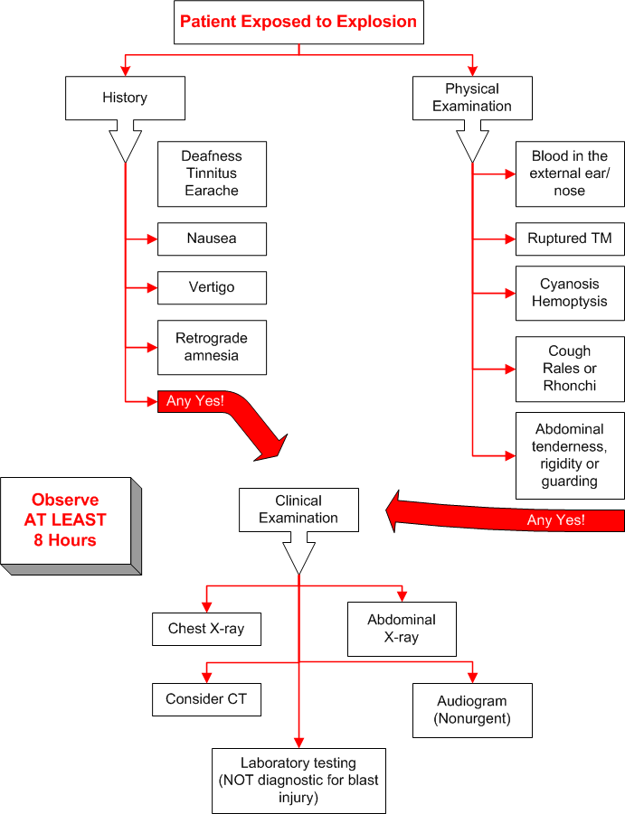

Table 5 - Treatment flow chart for blast injury

Tables
Profile of suicide bomber and possible physical appearance.
The United States guidance is that there “is no specific profile for those who have engaged in suicidal/homicidal bombings.⁷¹ The Israelis have had significantly more experience with this phenomenon and have established several guidelines and profiles.⁷² The Israeli profile for suicide/homicide bombers is as follows:
- 47% have an academic education and an additional 29% have at least a high school education.
- The suicide bomber undergoes a process of indoctrination that lasts for months – by the time that they are ready to don their explosives, they have reached a hypnotic state and believe that by blowing themselves up, and they have opened a direct gateway to heaven.
- 83% of the suicide/homicide bombers are single
- Most are males aged 16-30, although older males and females have been known to carry these devices.
  - 64% of the suicide bombers are between the ages 18-23, most of the rest are under 30.
Demeanor and appearance of a suicide/homicide bomber prior to attack:
- The effectiveness of a suicide/homicide bombing attack is often more related to the training and purpose of the bomber than the equipment used by the bomber.
  - May appear nervous, preoccupied, or have a blank stare.
  - Appears to be focused and vigilant
  - May be fervently praying to him/herself – giving the appearance of whispering to someone.
  - No response to authoritative voice or direct salutation
  - Behavior may be consistent with no future – unconcerned about receiving purchases or change.
  - The subject may walk with deliberation – but not running – towards a visible objective.
  - Demonstrate forceful actions (to reach a desired target by pushing their way through a crowd or into a restricted area)
  - Stiff movements, lack of mobility of lower torso or decreased flexibility (from wearing bomb device – although backpacks are increasingly common.)
  - May shave his or her head or have a short haircut. A short haircut or recently shaved beard or moustache may be evident by differences in skin complexion on the head or face. (This may be done to disguise appearance or to be better groomed when going to paradise.)
  - May smell of unusual herbal/flower water (in order to smell better when going to paradise)
- Clothing may be out of sync with the weather
- Clothing is often loose – clothing may give the impression that the body is disproportionately larger than the head or feet.
  - Devices are generally concealed within an article of clothing worn close to the body, such as a vest, belt, or jacket.
  - Backpack, bag, luggage, or briefcase may be carried.
  - The bomber is often holding a push-button or toggle switch to detonate the explosives. Alternative manual devices include a pull-type wire leading to the main device that triggers the detonation.
  - Many devices have a backup trigger system such as an electronic timer, pager, cell phone, or booby-trap type switch. If the attacker is killed, apprehended, or attempts to abort the attack, an accomplice/supervisor may remotely trigger the device.
  - The device will likely be filled with ball bearings, nails, screws, nuts or other small metal pieces. Dispersal of these fragments is the primary “kill” mechanism of the suicide/homicide bomber.
The first responsibility of responding officials should be to disperse any crowds. A search for a second device or perpetrator should be immediately started. If a suspicious person or item is identified, do not try to apprehend or move the object/person. Back off, try and get behind solid shielding and call for security personnel who are trained to deal with the threat.
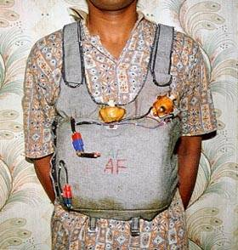
Figure 15 Suicide vest
- Suicide Vest Used by the LTTE – duel electric firing system, military grade explosives, ball bearings Photo courtesy of USCG.

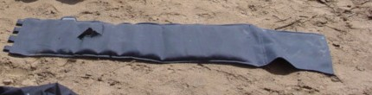
Figure 16 - Close up of Iraqi suicide vest
- Exterior View of Iraqi Suicide Vest Found in Baghdad.
Photo courtesy of USCG.
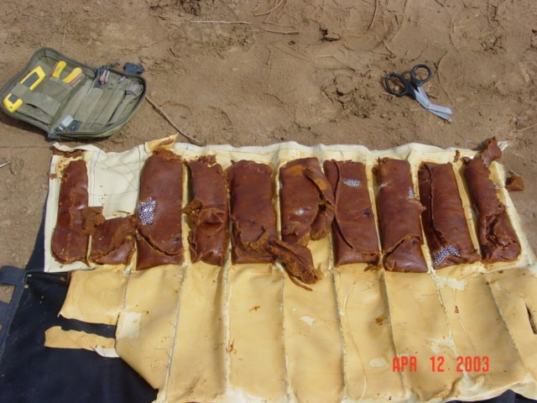
Figure 17 - Cutaway view of suicide vest
- Cutaway Showing Packages which Contain Main Explosive Charge and Ball Bearings for Fragmentation.
Photo courtesy of USCG.

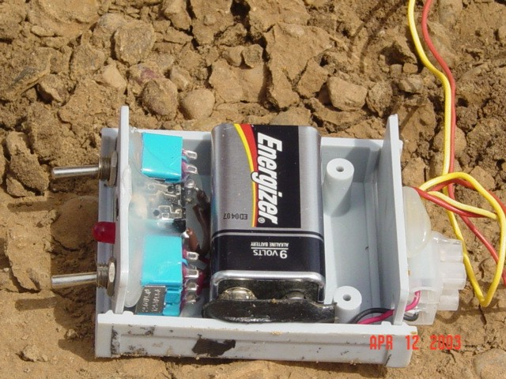
Figure 18 - Firing mechanism for suicide vest
- Firing Device with Lanyard Port, Two Toggle Switch Safety System, and 9V Battery.
Photo courtesy of USCG.

Possible Bomb Indicators
- Unusual device attached to a container or cylinder of flammable material
- Unusual looking or misplaced mailing containers leaking oil or with wiring attached.
- Abandoned vehicles or vehicles that do not appear to belong in the area.
- Strong chemical odors
- An unusual or out of place container
- Obvious bomb making materials: blasting caps, nitroglycerin, dynamite, wire or clock-timers
- Unattended packages or packs hanging on hooks in restrooms.
If a suspected bomb is discovered, do not touch or disturb it. Note the location, floor, and room. Report this at once to your fire or police and EVACUATE THE AREA!

Types of terrorist bombs:
Pipe bomb – A pipe bomb is a fragmenting bomb that is easily made. This type of bomb can be identified by a section of pipe capped at both ends. A fuse may extend from one end.
Bottle Bomb – A bottle bomb is often called a Molotov cocktail, after the Russian government official. It was a popular WWII anti-tank weapon. There are many different ways to make this device. The simplest is to fill a glass bottle with gasoline, use a sock or other rag stuffed in the end, and light the sock. When the bottle breaks, the gasoline is ignited.
Vehicle bomb. A vehicle is filled with explosives. When the explosives are detonated, a powerful explosion results. A small boat was used against the Cole, while Oklahoma City was a van used as a bomb.
Satchel (bag) bomb Several sticks of dynamite or other explosive are placed in a suitcase, briefcase, backpack or shoulder-strap bag. If one or two liquid propane cylinders are added to the bag, it increases the explosion and creates a fire. The bag can also be packed with antipersonnel material such as nails, screws, bolts, or nuts to inflict additional casualties. This kind of bomb can be left on a hook inside a restroom stall or in a locker. The 1996 Olympic Centennial Park bomb was a satchel bomb.
Suicide bomb. While any of the devices listed above, and many others can be used as a suicide bomb, the classic suicide bomb is a vest or belt filled with explosives and other material designed to increase fragment wounds. This is shown above.
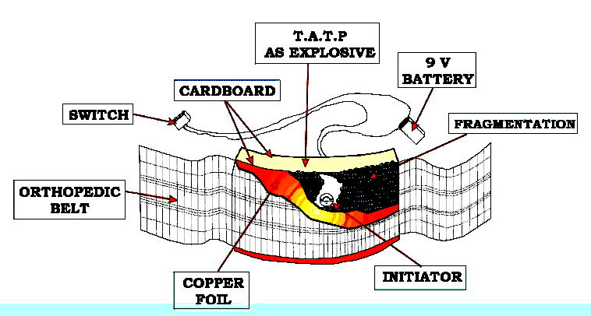
Figure 19 - suicide belt diagram
Courtesy of USCG.

Bomb “Stand-Off” Distances
 | Container or Vehicle Description | Maximum Explosives Capacity | Lethal Air Blast Range | Minimum Evacuation Distance | Falling Glass Hazard
 | Pipe 2” x 12” | 5-6 pounds |  | 850 feet  259 meters
 | 4” x 12” | 20 pounds
 | 8” x 24” | 120 pounds (uncommon)
 | Bottle 2 liter | 10 pounds
 | 2 gallon | 30 pounds
 | 5 gallon | 70 pounds  (uncommon)
 | Boxes  Shoebox | 30 pounds
 | Briefcase  Satchel bomb | 50 pounds |  | 1850 feet  564 meters | 1250 feet  381 meters
 | 1 cubic foot box | 100 pounds  (uncommon)
 | Suitcase | 225 pounds  (uncommon) |  | 1850 feet  564 meters | 1250 feet  381 meters
 | Compact sedan | 500 pounds (227 kilos) in trunk | 100 feet  30 meters | 1,500 feet  457 meters | 1250 feet  381 meters
 | Full size sedan | 1000 pounds  (455 kilos) in trunk | 125 feet  38 meters | 1,750 feet  534 meters | 1750  feet  534 meters
 | Passenger van or Cargo van | 4000 pounds  1818 kilos | 200 feet  61 meters | 2750 feet  838 meters | 2750 feet  838 meters
 | Small Box Van | 10000 pounds  4545 kilos | 300 feet  91 meters | 3750 feet  1143 meters | 3750 feet  1143 meters
 | Box Van or Water/fuel truck | 30000 pounds  13636 kilos | 450 feet  137 meters | 6500 feet  1982 meters | 6500 feet  1982 meters
 | Semi-trailer | 60000 pounds  27,273 kilos | 600 feet  183 meters | 7000 feet  2134 meters | 7000 feet  2134 meters

Table 6 Recommended stand-off distances for various explosive devices.
Information from ATF, Department of the Treasury, Bureau of Alcohol, Tobacco, and Firearms and The Technical Support Working Group.⁷³ ⁷⁴

Types and frequency found of small improvised explosive devices: ⁷³
Figure 20 Types and frequencies of small improvised explosive devices.

The blast lung injury severity score can be used to evaluate a patient with respiratory compromise following a blast injury.

Parameters:
- Ratio of PaO₂ to FIO₂
- Chest X-ray findings
- Presence of bronchopleural fistula
PaO₂ to FIO₂ ratio | Chest X-ray | Bronchopleural Fistula | Status of injury | Risk of ARDS | Risk of death from lung injury
>200 | Localized infiltrates | Absent | Mild | 0% | 0%
60-200 | Unilateral or bilateral infiltrates | Present or absent | Moderate | 33% | 0%
<60 | Massive bilateral infiltrates | Present | Severe | 75% | 75%
Table adapted from Rivkind AI, Luria T. Chapter 51: Blast injuries. In Demetriades D, Asensio JA, eds. Trauma Management. Landes Bioscience. 2000; p 544-552.
Therapy can then be adjusted according to the lung injury severity score.
Figure 21 - Blast lung scoring
Class I: | Class II: | Class III: | Indeterminate:
•Always acceptable, safe | •Safe, acceptable | •May be acceptable | • Continuing area of research
• Definitely useful  •Proven in both efficacy and effectiveness | • Probably useful | •Possibly useful  •Considered optional or alternative treatments | •No recommendations until further research
Level of Evidence: | Level of Evidence: | Level of Evidence: | Level of Evidence:
• One or more large prospective studies are present (with rare exceptions) | • Generally higher levels of evidence | • Generally lower or intermediate levels of evidence | •Evidence not available
• High-quality Meta-analyses | • Non-randomized or retrospective studies: Historic, cohort or case-control studies | • Case series, animal studies, consensus panels | •Higher studies in progress
•Study results consistently positive and compelling | • Less robust RCTs | • Occasionally positive results | •Results inconsistent, contradictory
 | • Results are consistently positive |  | •Results not compelling
Figure 22 - Classification of evidence-based medicine used in this article.

Many materials form dust clouds that can ignite and explode, injuring personnel and damaging equipment. This is a well-publicized occurrence in the coal mining, grain storage, and the woodworking and paper industries. Many miners have been killed and injured and massive production losses have resulted from coal dust explosions in underground coal mining operations. 129 grain dust explosions occurred nationwide between 1987 and 1997. Of these dust explosions, about half involved corn and corn products. Eleven were caused by wheat dust and 10 by dust from soybeans.
A google search on this topic yielded over 265,000 entries.
A BLEVE is a type of pressure-release explosion that occurs when liquefied gases, which are stored in containers at temperatures above their boiling points, are exposed to the atmosphere, causing rapid vaporization. The result is the mixing of vapor and air that results in the characteristic fireball that occurs when the fire ignites the vapor. This happens when a container fails or is ruptured by an accident. A BLEVE can also occur when flame impinges on the tank shell at a point or points above the liquid level of the tank's contents. The heat from the fire causes the metal to weaken and fail as the internal pressure increases.
These fragments are often erroneously referred to as “shrapnel.” Shrapnel is the name for an artillery round containing multiple round lead balls that was designed during WWI by the then Lt. Shrapnel. This round essentially functions as a very large shotgun with several hundred half-inch lead balls.
Although bomb “capacities” have been listed for improvised devices, the reader should realize that the bomb maker is not limited to these dimensions and may use different materials with smaller or larger capacities. Remember that for pipe bombs, in particular, bomb makers may often use multiple containers. Standoff distances for improvised devices that are not given may be estimated from given distances for smaller and larger devices. When estimating, a larger standoff distance is safer!
The table is built from several ATF and TSWG publications. I am unsure why they have a larger standoff distance for a briefcase than for a small car. Certainly by explosive weight, this distance should be about midway between the car and the pipe bomb…
The table is built from several ATF and TSWG publications. I am unsure why they have a larger standoff distance for a suitcase than for a small car. Certainly by explosive weight, this distance should be about midway between the car and the pipe bomb…

