Tornadoes
”The Most Violent Storm”
Written for
The Oklahoma Institute of Disaster and Emergency Medicine

by
Charles Stewart MD
Associate Professor of Emergency Medicine
University of Oklahoma, Tulsa
Director of Research
Oklahoma Institute of Disaster and Emergency Medicine
Charles Stewart MD  Shusterman Center  4502 East 41st Street  Suite 2E06  Tulsa, OK 74135  Work: 918-660-2828  Fax: 918-660-3821  charles-e-stewart@ouhsc.edu | © Charles Stewart and  Associates, 2026  10909 S. Quebec Place  Tulsa, OK 74137  Voice: 918-296-3789  Cell: 918-344-4557  work@storysmith.net

Document Title: 0000.doc

Document Size: 0 words

Copyright to this work is retained by the Author, but the work may be freely copied for educational purposes
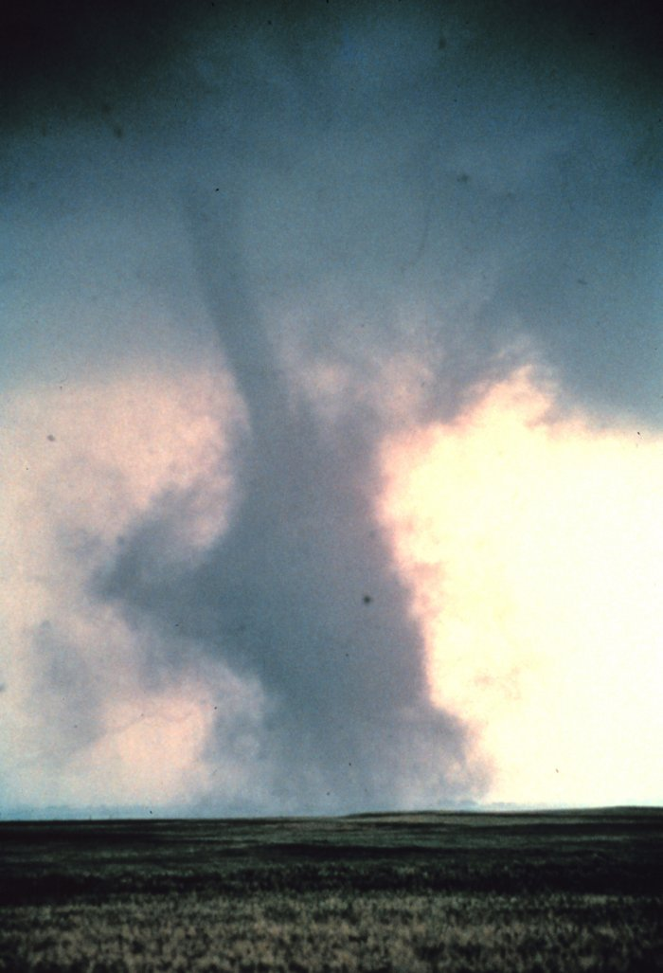

Introduction
The United States National Weather Service defines a tornado as "a violently rotating column of air in contact with the ground and pendant from a thunderstorm." A tornado is not necessarily visible, but the intense low pressure caused by the high wind speeds and rapid rotation will usually cause the water vapor in the air to condense into a visible funnel shaped cloud. The tornado is actually the vortex of wind that is in contact with the ground, not the funnel cloud. A funnel cloud is the condensation of water vapor and may have no strong winds at the surface. Most tornadoes produce strong winds at the surface of the ground even while the visible funnel cloud may still be above the ground, so it is difficult to separate the funnel cloud and the tornado. For practical purposes, if the funnel cloud exists, so does a tornado.
The damage from a tornado is a result of the high wind velocity and wind-blown debris. Tornadoes can touch the ground with winds greater than 300 miles per hour. Even though winds from the strongest tornadoes far exceed that from the strongest hurricanes, hurricanes typically cause much more damage individually and over a season, and over far bigger areas. Economically, tornadoes cause about a tenth as much damage per year, on average, as hurricanes. Hurricanes tend to cause much more overall destruction than tornadoes because of their much larger size, longer duration and their greater variety of ways to damage property. The destructive core in hurricanes can be tens of miles across, last many hours and damage structures through storm surge and rainfall-caused flooding, as well as from wind. Tornadoes, in contrast, tend to be a few hundred yards in diameter, last for minutes and primarily cause damage from their extreme winds.

Historical Examples
1990 Plainfield, Crest Hill, and Joliet IL
This was an F5 storm with course 16.5 miles long and width of 700 yards. There was no tornado warning issued and the tornado occurred between 3:15 and 3:45 PM in Will County, Illinois. The tornado caused loss of power to 65,000 homes and businesses, loss of phone service to 10,000 residences, and over $200 million in damages. It was the worst tornado in Illinois history and one of the most violent storms in United States history. 302 people were injured. Of these, 80 were hospitalized and survived and 28 died.

Of the patients who were treated and released, 221 were treated in one emergency department and 38 at a second. The rest were distributed among outlying hospitals. The inequality occurred because of self-referral to a single hospital rather than EMS transport.
- 37.9 were younger than 20 years of age
- 9.7% were older than 65.
In earlier studies, persons older than 65 were more likely to be injured than persons under 20, presumably due to pre-existing medical illnesses, decreased mobility, dcreased comprehension of warnings, and greater susceptibility to injury from lower level mechanical forces.

1999 May 3: Bridge Creek/Moore, OK
The strongest tornado ever recorded (F5) moved through the Oklahoma City suburbs of Bridge Creek and Moore in the late afternoon hours. This tornado killed 38 people and injured hundreds. A total of 69 tornadoes occurred from this outbreak. The tornado’s path was judged to be more than a mile wide at times. A Doppler radar On Wheels (DOW) team measured a 318 mph wind speed in this tornado, the highest measured wind speed ever recorded within a tornado. The National Weather Service was able to give Moore residents 35 minutes warning before this tornado impacted. Total damages exceeded $1.1 billion.

2001 April 21: Hoisington, KS
An F4 tornado moved into the Kansas community of Hoisington. One person was killed, 28 injured, and nearly $43 million in damage was done from this tornado. No tornado warning had been issued for this community when the tornado struck. Most people were home watching local TV stations and were told to take cover, even though a tornado warning had not been issued.

2003 May 4 – May 11: Plains Into The Southeast
A deadly outbreak of severe weather occurred between May 4th and May 11th, producing hundreds of tornadoes and widespread reports of large hail and damaging winds across eight states. Tornadoes affected the metropolitan areas of Kansas City and Oklahoma City, producing F3 and F4 damage. Other cities including Pierce City, Missouri and Jackson, Tennessee sustained heavy damage and loss of life. At least 38 people were killed from the outbreak in Kansas, Missouri and Tennessee. In Oklahoma City, damaging tornadoes occurred on both the 8th and 9th. May 1st through the 11th had more reported tornadoes (412) than any other ten-day period since records began in 1950. The estimated total damages from this historical outbreak totaled more than $3.2 billion.

2007 May 4: Greensburg, KS.
10 deaths occurred from this tornado. At least 60 people were injured in Greensburg alone. About 95 percent of the town of 1,500 was destroyed by an EF5 tornado with estimated wind speeds of about 205 miles per hour. This was probably the strongest tornado of an outbreak that spanned several states with tornadoes reported across Oklahoma, Colorado, Kansas and South Dakota. NOAA forecasters in Dodge City were able to issue a Tornado Warning 39 minutes before the 1.7 mile wide wedge tornado hit the town. Noting intensification in radar images and a bearing directly toward Greensburg, Dodge City weather staff updated the Tornado Warning with a Tornado Emergency message 10-12 minutes before the twister hit urging residents to get to shelter immediately.

Path of the May 4, 2007 Greensburg, KS Tornado Rated EF-5
(The First "5" Rating on the new Enhanced-Fujita Scale)
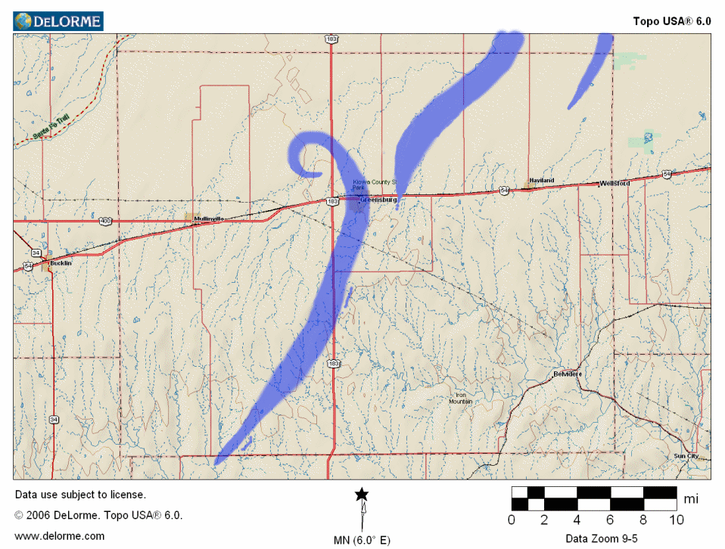

Geographical Distribution
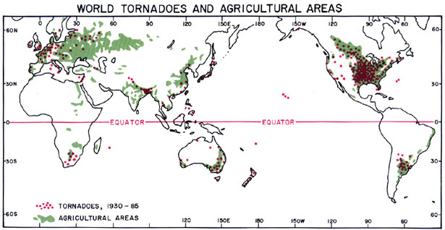
The majority of tornadoes occur in agricultural areas. Thunderstorms need moisture to grow and to spawn tornadoes and they also need the instability associated with spring and summer warming. Crops need moisture to grow and the temperature variation associated with changing seasons. Both conditions for tornadoes and agricultural growth are found in the same areas, as is shown on this map. (Courtesy of Dr. T. T. Fujita, University of Chicago)
The United States averages about 1,200 tornadoes per year. A distant second is Canada, with around 100 per year. Other locations that experience frequent tornado occurrences include northern Europe, western Asia, Bangladesh, South Africa, far eastern Asia and Japan, Argentina, Paraguay and Southern Brazil, Australia and New Zealand. In fact, the United Kingdom has the most tornadoes per land area with an average of about 30 per year. Fortunately, most UK tornadoes are relatively weak.
Bangladesh and the surrounding areas of eastern India suffer from tornadoes of equal severity to those in the United States. These tornadoes are often under-reported due the third-world reporting biases. In Bangladesh, there are about 180 people per year killed by tornadoes. This high number may be due to a high population density coupled with poor construction practices, and local lack of knowledge about tornadoes and tornado safety.
Although the probability that a tornado will strike any specific location is extremely small (probability 0.0363), some areas, such as the Midwest states in the United States, are particularly vulnerable. Globally, the middle latitudes, between about 30° and 50° latitude, provide the most favorable conditions for tornadoes to form. This is the region where cold, polar air comes up against warmer, subtropical air, and often where airflow at different levels of the lower atmosphere means wind shear may impart rotation to a storm cell. Interestingly, the places that receive the most frequent tornadoes are also considered the most fertile agricultural zones of the world. This is due in part to the high number of thunderstorms delivering much needed precipitation to these areas. Simply as a result of all these thunderstorms, the odds are increased that some of these storms will produce tornadoes.
In the United State, the unique geography of the North American continent promotes tornadoes. North America is a relatively large continent that extends from the arctic in the north to the tropics in the south. There are no major east-west mountain ranges in the continent to block air flow from north to south. In the middle latitudes, the Rocky Mountains trap moist air from the West with precipitation on the Western Slopes of the Rockies This causes the air to be drier at the mid-level troposphere. The Rockies also promote cyclogenesis to the east of the mountains. The desert South-West United States also feeds drier air to the troposphere. The southern Gulf of Mexico provides abundant low-level moisture as a counterpart to the higher, drier air. This collision of warm moist air and dry cool air provides the conditions that breed strong mesocyclone storms many times throughout the year.
The highest number of tornadoes occurs in the southern plains of the United States (also called Tornado Alley), –where the moist air from the Gulf of Mexico meets the dry high air spinning off of the Rockies. Other high tornado areas in the United states are south of Lake Michigan, and in west central Florida.
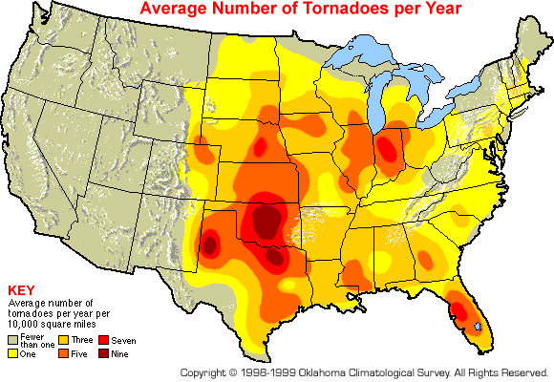
Figure 7t-8: Average number of tornadoes per year in the United States. (Source: Oklahoma Climatological Survey).
Because a tornado is part of a severe thunderstorm, and thunderstorms occur all over the Earth, tornadoes are not limited to any specific geographic location. Then, if other conditions are right, the thunderstorm could spin out one or more tornadoes. In fact, tornadoes have been documented in every one of the United States, and on every continent, with the exception of Antarctica (even there, a tornado occurrence is not impossible). In fact, wherever the atmospheric conditions are right, the occurrence of a tornadic thunderstorm is possible.

Natural Preconditions for Disaster Occurrence
Conditions favorable for tornado development often occur over the United States Plains States during spring and summer. As the season goes on, tornadoes are likely farther and farther north on the Plains and in the Midwest, but in April and May tornadoes are common in both the South and on the Plains and in the Midwest. Strong tornadoes occasionally occur in northern Mexico. Often, a large storm system can create tornado conditions for several days in a row.
Tornadoes are most common in spring and least common in winter. Since autumn and spring are transitional periods from warm to cool and vice versa, there are abundant chances of cooler air meeting warmer moist air, creating thunderstorms and increased risk of tornadoes.
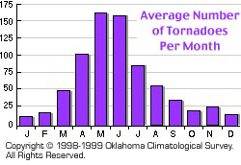
Figure 7t-9: Average number of tornadoes per month of year in the United States. (Source: Oklahoma Climatological Survey).
Tornadoes can also be caused by landfall of a tropical cyclone. This increases the number of late summer and autumn tornadoes.
Destructive tornadoes can occur at any time of day, but tornado occurrence is usually dependent on the time of day because of solar heating of the air. Worldwide, most tornadoes occur in the late afternoon, between 1500 and 1900 (3-7 PM) local time. A peak occurs about 5 PM.
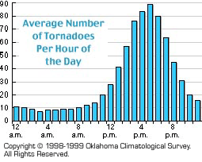
Figure 7t-9: Average number of tornadoes per hour of the day in the United States. (Source: Oklahoma Climatological Survey).

The Disaster-Producing Event
A typical tornado outbreak often features an intense upper-level disturbance moving across the Plains during spring. This disturbance provides the strong vertical wind shear that gives an updraft its twisting motion, turning a normal thunderstorm into a potentially tornado spawning supercell.
How a tornado works
- A large, thermally stratified situation develops in the atmosphere, with hot, humid air trapped beneath cold, dry air.
- For some reason, the "cap," (the stable layer of air between the hot and cold air) is disturbed. The disturbance can be caused by an upper-level air disturbance, or the arrival of a front.
- As the lower-level air rises, it expands in the reduced air pressure aloft (air pressure drops as altitude increases), and it cools. Eventually, the cooling causes the moisture to condense .
- Condensation releases latent heat, warming the air, making it buoyant, and causing it to rise quickly (at speeds up to 150 mph). By now, the cloud has formed into a thunderstorm. Upper-level winds tilt the thunderhead to create the anvil at the top.
- The thunderstorm may die out in intense rain and/or hail. Or it may spawn a tornado.
- Interactions between air at various altitudes, humidities and temperatures causes rain, lightning, air circulation and an intensification of the rotating updraft, called a "mesocyclone." Mesocyclones are located a few miles up in the atmosphere and may be 1-6 miles across (2-10 km). Low-level wind helps cause this rotation, which is almost always counter-clockwise (seen from above) in the Northern Hemisphere.
- A tornado may form below the mesocyclone. As the spinning column of air narrows, it rotates faster and extends higher into the storm.

Appearance
Tornadoes can appear in many shapes and sizes. The average tornado has a track approximately 2 miles long and 50 yards wide, affecting about 0.06 square miles and with wind speeds as high as 300 mph. Most tornadoes are a narrow funnel a few hundred meters (yards) across, with a small cloud of debris at the cloud-ground contact point. Large single-vortex tornadoes can look like wedges attached to the ground. These wedges can be so wide that it appears to be a block of dark clouds. Some tornadoes can be completely obscured by the precipitation associated with the mesocyclone or the dust blown up by the winds. Tornadoes that are dissipating can resemble narrow tubes or ropes. These tornadoes may twist into complex shapes.
Tornadoes can very widely in color depending on the debris they pick up, the amount of precipitation, and the lighting. Condensation tunnels with little debris are often white or gray. Waterspouts and tornadoes over snow can be white or even blue. The red Great Plains soils may color the funnel cloud reddish. Tornadoes that pick up substantial debris may be dark gray or even black. Back-lit tornadoes appear very dark. Tornadoes that occur during sunset can be multicolored.
Multiple eyewitness accounts note that tornadoes have a clear, calm center like the eye of a hurricane. This area may be full of dust, has light winds, and is often quite dark due to the swirling debris on the outside of the tornado. Lightning may illuminate the ‘eye’ of the tornado.
Occasionally, a single storm may produce multiple tornadoes. This process is called cyclic tornadogenesis. These tornadoes formed from the same storm are also referred to as a tornado family. Occasionally, separate distinct mesocyclones can produce simultaneous tornadoes. A multiple vortex tornado is a type of tornado where two or more columns of spinning air rotate around a common center. This multivortex structure is most often observed in intense tornadoes and may be obscured by condensation, dust, and debris, appearing to be a single funnel cloud.
A waterspout is simply a tornado over water. Researchers may divide waterspouts into fair weather waterspouts that occur at the base of cumulus congestus cloud towers in tropical and semitropical waters. These have relatively weak winds, smooth walls, and travel very slowly. Tornadic waterspouts are literally tornadoes over water and form just like tornadoes over land.
Mesocyclones that form tornadoes often have very heavy rain, frequent lightning, strong wind gusts and may have hail. These storm effects may obscure the formation, path, and characteristics of tornadoes.

Frequency and Duration
In the United States, tornadoes are about 150 meters (500 feet) across and stay on the ground for 8-10 km (5-6 miles). Unfortunately, there is a very large range in tornado sizes. Weak tornadoes or tornadoes that are dissipating can have a damage path of only a few feet. On the other hand, wedge tornadoes can damage a path greater than a mile across (1.6 km across).
Tornadoes may last for extended duration. The Tri-State tornado in 1925 was officially on the ground for 219 (350 km) continuous miles.
Tornado damage is measured on the F-Scale (Fujita Scale or Fujita-Pearson Tornado Scale) This scale is named after the most noted researcher of tornadoes, Dr. Fujita of the University of Chicago. The scale ranges from F0 (very weak) to F12 (at wind speed of Mach 1, an unimaginable force). The strongest tornadoes observed to date have been F5 (261-318 mph).
Fujita Pearson Tornado Scale
(This scale is expanded considerably in table x) at the end of this article.
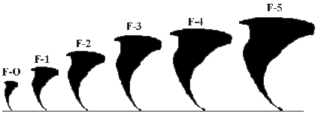
F-0
40-72 mph, chimney damage, tree branches broken
F-1
73-112 mph, mobile homes pushed off foundation or overturned
69% of all tornadoes are F0-F1.
These tornadoes cause less than 5% of all tornado-related deaths
The average lifetime of the weak tornado is 1-10 minutes
F-2
113-157 mph, considerable damage, mobile homes demolished, trees uprooted
F-3
158-205 mph, roofs and walls torn down, trains overturned, cars thrown
29% of all tornadoes are F2-3. These tornadoes cause nearly 30% of all tornado deaths and may last as long as 20 minutes.
F-4
207-260 mph, well-constructed walls leveled
F-5
261-318 mph, homes lifted off foundation and carried considerable distances, autos thrown as far as 100 meters
Only 53 F-5 tornadoes have been measure to date in the United States since 1950 while Canada has had only 1 official F5 tornado.
(a list can be found at http://www.spc.noaa.gov/faq/tornado/f5torns.html )
Over the years, the F-Scale has revealed the following weaknesses:
It is subjective based solely on the damage caused by a tornado
No recognition in difference in construction
Difficult to apply with no damage indicators
if the 3/4-mile wide tornado does not hit any structures, what F-scale should be assigned?
Subject to bias
Based on the worst damage (even if it is one building or house)
Overestimates wind speeds greater than F3
And the F-Scale has had its misuses over the years:
Too much reliance on the estimated wind speeds
Oversimplification of the damage description
Judge the F-scale by the appearance of the tornado cloud
Unrecognizing weak structures
mobile homes
modified homes
Fujita recognized that improvement was necessary. He published his memoirs called Mystery of Severe Storms in 1992 updating the Fujita Tornado Scale to include an estimate of f-scale damage then selecting the F-scale as a combination of f-scales and types of structural damage. An update to the original F-scale by a team of meteorologists and engineers, was implemented in the U.S. on 1 February 2007. The Enhanced Fujita scale is based on 28 factors and is considered more replicable and accurate than the F-Scale. Since no storms greater than F-5 have been recorded, the enhanced F-scale stops at F-5.

Forecasting and Forewarning

Forecasting
While data is available to indicate where past tornado events have occurred, most of the data does not provide accurate enough locations to be able to map with reliability where tornadoes have occurred or where they are liable to occur.
The United States National Weather Service generally can't rely on tornado reports from untrained observers. Since most people don't have any weather observation training, they may not actually see what they think they see. The United States Weather Service offers classes to become part of a network of trained volunteer spotters called SKYWARN. Meteorologists can feel confident about the accuracy of the trained SKYWARN spotter reports. If a tornado is spotted, they can issue a tornado warning with a good degree of confidence.
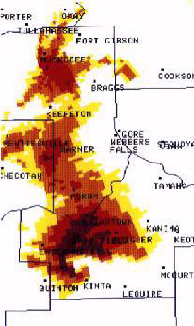
Mesocyclone “hook-shaped echo” associated with tornadoes.
(Image courtesy of the National Weather Service Forecast Office in Tusla, Oklahoma)
On conventional radar, a hook-shaped echo was the only sign that a tornado might form. Two problems were that not all tornadoes showed up as hook echoes and that sometimes tornadoes were on the ground before the hook showed up on radar screens. The hook itself is actually a mesocyclone, a region of rotation and rising air that is free of precipitation. That's why it shows up on radar and being clear. Mesocyclones are what make supercells last so long. They also have been known to cause tornadoes, which is why forecastors would look for this shape on radar.

Forewarning
In the United States and Canada, warning of a tornado is given in two phases:
A Tornado Watch is a message that indicates that the conditions are favorable for formation of a tornado. Since tornadoes are spawned from severe thunderstorms, a tornado watch therefore implies that it is also a Severe Thunderstorm Watch. The watch boxes (or weather watches, WWs) are usually issued in the format of x miles north and south, or east and west, or either side of a line from y miles direction of city, state, to z miles another direction of another city, state. For example: "50 miles either side of a line from 10 miles northeast of Columbia, South Carolina to 15 miles south-southwest of Montgomery, Alabama". ("Either side" means perpendicular to the center line.) In addition, a list of all counties included in its area of responsibility is now issued by each NWS forecast office for each watch.

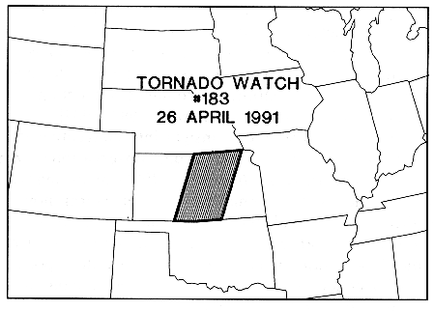
Map of Tornado Watch #183 for 26 April, 1991

When severe hail (at least 3/4-inch diameter), damaging winds (at least 50 knots or 58 mph) appears imminent, local NWS offices will issue a Severe Thunderstorm Warning. The warning is rapidly disseminated over NOAA Weather radio, commercial radio and TV stations and news wires, so that people in the warning area can find safe shelter to take cover from the storm.

If a tornado is sighted by SKYWARN watchers or the Doppler radar picture shows the characteristic ‘hook’ of a tornado (threshold strong with a tight rotation signature), then a Tornado Warning is issued. A tornado warning means there is immediate danger for the warned and the immediately surrounding area (since the path may not be completely predictable) -- if not from the relatively narrow tornado itself, from the severe thunderstorm it. All in the path of such a storm are urged to take cover immediately, as it is a life-threatening situation. A tornado warning will also be issued if a tropical cyclone is making landfall with winds in excess of 115 miles per hour (185 KPH). When a tropical cyclone makes landfall both the extreme wind and the likelihood of accompanying tornados can cause damage.

In the event that the conditions that lead to a tornado watch are likely to form a major outbreak of tornados along with the thunderstorm’s destructive winds and hail, the tornado or thunderstorm watch may be enhanced with the words particularly dangerous situation (PDS) added to the watch.

When a particularly large tornado is about to impact a densely populated area, the Weather Service may issue the tornado warning with the enhanced wording; TORNADO EMERGENCY. A tornado emergency enhanced wording is added to a standard Tornado Warning and contains the phrase "This is a Tornado Emergency for..." and specific information about the areas in the path. This wording has been used four times in U.S. history: for the F5 tornado that hit Moore, Oklahoma in 1999; for the F4 tornado that hit Moore, Oklahoma, again in 2003; for the F4 Tornado that hit western Oklahoma City the next day in 2003; and for the EF5 that hit Greensburg, Kansas in 2007. Since information about the tornado and its exact path is often determined after the initial Tornado Warning is issued, this designation may also be added to the Severe Weather Statement (SVS) that is used to follow-up the initial Tornado Warning.

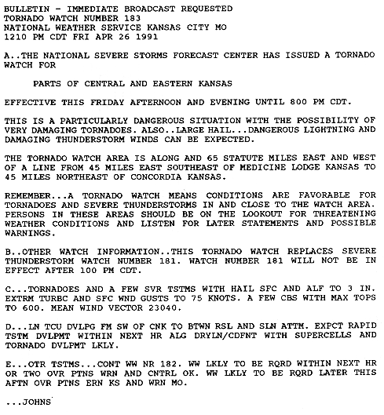
Wording of the Tornado Watch #183 as shown in the map above. Please note that this watch uses the “PDS – Particularly Dangerous Situation enhanced wording.”

Forecasting Ability

Impact on Built and Natural Environments
Damage caused by tornadoes is rated after the tornado has passed with either the Fujita scale, the enhanced Fujita scale, or the TORRO scale. (See appendix 1(Fujita) and appendix 2(TORRO) scales) The most volent tornadoes have rotating winds of 250 miles per hour or more. They are capable of extreme destruction, including uprooting fully grown trees, destroying well made structures, and turning objects into lethal missiles. Although violent tornadoes are only 2% of all tornadoes, they are responsible for nearly 70% of tornado-related fatalities.

Disaster Mitigation
Studies have shown that people in mobile homes and in lightweight cars when tornadoes strike are at particularly high risk. In the Wichita Falls, Texas, Tornado Study, occupants of mobile homes were 40 times more likely to sustain a serious or fatal injury than those in permanent dwellings, and occupants of automobiles were at approximately five times greater risk (Glass, Craven and Bregman 1980). The leading cause of death are craniocerebral trauma, followed by crushing wounds of the head and trunk. Fractures are the most frequent form of non-fatal injury (Mandlebaum, Nahrwold and Boyer 1966; High et al. 1956). Those workers who spend a major part of their working time in lightweight automobiles, or whose offices are in mobile homes, would be at high risk.

Evacuation
The issuing of appropriate warnings, and the need for the population to take appropriate action on the basis of those warnings, are the most important factors in preventing tornado-related death and injury. In the United States, the National Weather Service has acquired sophisticated instrumentation, such as Doppler radar, which permits them to identify conditions conducive to the formation of a tornado and to issue warnings. A tornado watch means that conditions are conducive to tornado formation in a given area, and a tornado warning means that a tornado has been sighted in a given area and those residing in that area should take appropriate shelter, which entails going to the basement if one exists, going to an inside room or closet, or if outside, going to a ditch or gully.
Research is needed to assess whether warnings are effectively disseminated and the extent to which people heed those warnings. It should also be determined whether the prescribed shelter areas really provide adequate protection from death and injury. Information should be gathered on the number of deaths and injuries to tornado workers.

Preparedness and Response
Because tornadoes can occur so quickly, communities should develop redundant warning systems (e.g., media alerts and automated telephone warnings), establish protective shelter to reduce tornado-related injuries, and practice tornado-shelter drills. In the event of a tornado, the residents should take shelter in a basement if possible, away from windows, while protecting their heads. Special outreach should be made to people with special needs who can make a list of their limitations, capabilities, and medications and have ready an emergency box of needed supplies. People with special needs should have a "buddy" who has a copy of the list and who knows of the emergency box.

0. Develop your plan for home, school, work BEFORE the storm hits.
- Ensure that you have frequent drills
- Have a NOAA weather radio with a warning alarm tone and battery back-up to receive warnings
- Ensure that you have a disaster kit at-hand where you spend your time.

1. BE ALERT: Know what is going on with the weather. Stay tuned to local media outlets such as television or radio. If neither of these will be accessible, take a portable NOAA weather radio. Know what to look and listen for if threatening weather approaches, such as:
- a greenish-black tint to the sky
- rapidly-rotating clouds converging on a single point
- a low-hanging cloud that looks to be rotating
- a strange quiet followed by a sound like a waterfall or rushing air.
- a sound like a railroad train or jet engine
- objects such as branches and leaves being pulled upwards
- debris dropping from the sky

Be sure to inform the blind or deaf about the weather conditions. Alert the elderly and ill about the impending weather situation as well.

2. BE OBSERVANT OF YOUR SURROUNDINGS: There are several places that should NOT be considered as safe when a tornado is approaching. Seek shelter in another area if time allows if you are in a (an):
- mobile home
- car or truck
- auditorium
- open field
- high-rise building

Initial Response
3. If a warning is issued or if threatening weather approaches, seek shelter. This may be the most important decision in your life. The safest place to be in a tornado is a basement or underground tornado-proof shelter. If neither of these are accessible, the inner-most and lowest room of a building, such as a closet or bathroom, provides some shelter. Keep as many walls as possible between you and the tornado. Cover yourself with blankets or sofa cushions to protect you from flying debris.
- In a home or building, move to an underground sheltered area such as the basement.
- If an underground shelter is not available, move to an interior room or hallway on the lowest floor and get under a sturdy piece of furniture.
- Stay away from windows
If you cannot find shelter indoors, get to a ditch or ravine, crouch into a fetal position, and cover your head. Abandon your vehicle immediately!
- Get out of automobiles!
- Do not try to outrun a tornado in your care, instead, find a ditch or depression.
- Do not seek shelter under an underpass
- Mobile homes offer little protection from tornadoes and should be abandoned.

Occasionally, tornadoes develop so rapidly that advance warning is not possible. Remain alert for signs of approaching storms and tornadoes during the season.

Flying debris from tornadoes causes most deaths and injuries.

Impact-related injury or death is defined as an injury or death that is caused by the direct mechanical effects of the tornado. Post-impact injuries are injuries or deaths that occur within 48 hours of the tornado that would not have occurred in the absence of the tornado. Examples include injuries sustained by walking through debris, during cleanup, or as a result of loss of electrical power.

Types of Injuries that commonly occur due to a tornado:
Most common injuries
- Trauma to head, extremities, and thorax.
- Severe lacerations and abrasions.
It is often impossible to determine if these injures are due to high-velocity projectiles propelled by the wind or by collapse of the structures.
Most deaths and injuries occur during impact phase of tornado, but some will happen during cleanup/remediation.

Secondary Response

Summary

Illustrations

References

Appendix 1 Fujita Enhanced F Scale for Tornado Damage
An update to the original F-scale by a team of meteorologists and wind engineers, was implemented in the U.S. on 1 February 2007.

FUJITA SCALE |  |  |  | Derived Enhanced Fujita Scale |  | Operational Enhanced Fujita Scale
F Number | Fastest 1/4-mile  Kph  (mph) | 3 Second Gust (mph) | Comments | EF Number | 3 Second Gust (mph) | EF Number | 3 Second Gust (mph)
0  Weak | 65-118  (40-73) | 45-78 | Damage is light. Chimneys on houses may be damaged; trees have broken branches; shallow-rooted trees pushed over; some windows broken; damage to sign boards. | 0 | 65-85 | 0 | 65-85
1  Weak | 119-181  (74-112) | 79-117 | Shingles on roofs blown off; mobile homes pushed off foundations or overturned; moving cars pushed off roads. | 1 | 86-109 | 1 | 86-110
2  Strong | 182-253  (113-157) | 118-161 | Considerable damage. Roofs torn off houses; mobile homes destroyed; train boxcars pushed over; large trees snapped or uprooted; light-objects thrown like missiles. | 2 | 110-137 | 2 | 111-135
3  Strong | 254-332  (158-206) | 162-209 | Damage is severe. Roofs and walls torn off better constructed homes, businesses, and schools; trains overturned; most trees uprooted; heavy cars lifted off ground and thrown some distance. | 3 | 138-167 | 3 | 136-165
4  Violent | 333-419  (207-260) | 210-261 | Better constructed homes completely leveled; structures with weak foundation blown off some distance. | 4 | 168-199 | 4 | 166-200
5  Violent | 420-513  (261-318) | 262-317 | Better constructed homes lifted off foundations and carried considerable distance where they disintegrate; trees debarked; cars thrown in excess of 100 meters. | 5 | 200-234 | 5 | Over 200
6  Unimaginably Violent | Although F6 and above are theoretically possible in the Fujita scale, they are not used |  |  | N/A – The enhanced Fujita scale does not provide for greater than F5 |  | N/A
*** IMPORTANT NOTE ABOUT ENHANCED F-SCALE WINDS: The Enhanced F-scale still is a set of wind estimates (not measurements) based on damage. Its uses three-second gusts estimated at the point of damage based on a judgment of 8 levels of damage to the 28 indicators listed below. These estimates vary with height and exposure. Important: The 3 second gust is not the same wind as in standard surface observations. Standard measurements are taken by weather stations in open exposures, using a directly measured, "one minute mile" speed.

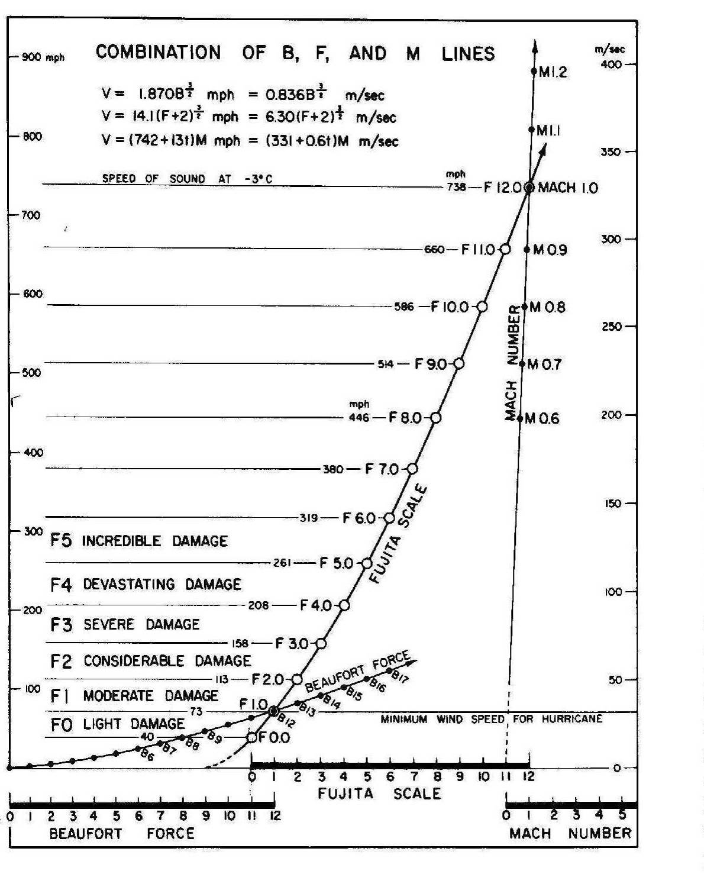

Appendix 2 TORRO T-SCALE - The International Tornado Intensity Scale (Primarily used in Great Britain)
Tornado Intensity | Description Of Tornado & Windspeeds | Description Of Damage (for guidance only)
T0 | Light Tornado  17 - 24 m s-1  (39 - 54 mi h-1) | - Loose light litter raised from ground level in spirals.  - Tents, marquees, awnings seriously disturbed.  - Some exposed tiles, slates on roofs dislodged. Twigs snapped; trail visible through crops.  - Wheelie bins tipped and rolled.  - Garden furniture & pots disturbed.
T1 | Mild Tornado  25 - 32 m s-1  (55 - 72 mi h-1) | - Deck chairs, small plants, heavy litter becomes airborne.  - Minor damage to sheds.  - More serious dislodging of tiles, slates.  - Chimney pots dislodged. Wooden fences flattened.  - Slight damage to hedges and trees.  - Some windows already ajar blown open breaking latches.
T2 | Moderate Tornado  33 - 41 m s-1  (73 - 92 mi h-1) | - Heavy mobile homes displaced. Light caravans blown over.  - Garden sheds destroyed. Garage roofs torn away and doors imploded.  - Much damage to tiled roofs and chimneys. Ridge tiles missing.  - General damage to trees, some big branches twisted or snapped off, small trees uprooted.  - Bonnets blown open on cars.  - Weak or old brick walls toppled.  - Windows blown open or glazing sucked out of frames.
T3 | Strong Tornado  42 - 51 m s-1  (93 - 114 mi h-1) | - Mobile homes overturned / badly damaged. Light caravans destroyed. Garages and weak outbuildings destroyed.  - House roof timbers considerably exposed. Some of the bigger trees snapped or uprooted.  - Some heavier debris becomes airborne causing secondary damage breaking windows and impaling softer objects.  - Debris carried considerable distances. Garden walls blown over.  - Eyewitness reports of buildings physically shaking.  - Mud sprayed up the side of buildings
T4 | Severe Tornado  52 - 61 m s-1  (115 - 136 mi h-1) | - Motorcars levitated. Mobile homes airborne / destroyed.  - Sheds airborne for considerable distances. Entire roofs removed from some houses.  - Roof timbers of stronger brick or stone houses completely exposed. Gable ends torn away.  - Numerous trees uprooted or snapped. Traffic Signs folded or twisted.  - Some large trees uprooted and carried several yards.  - Debris carried up to 2km leaving an obvious trail.
T5 | Intense Tornado  62 - 72 m s-1  (137 - 160 mi h-1) | - Heavier motor vehicles (4x4, 4 Tonne Trucks) levitated.  - Wall plates, entire roofs and several rows of bricks on top floors removed.  - Items sucked out from inside house including partition walls and furniture.  - Older, weaker buildings collapse completely.  - Utility poles snapped.
T6 | Moderately-Devastating Tornado  73 - 83 m s-1  (161 - 186 mi h-1) | - Strongly built houses suffer major damage or are demolished completely.  - Bricks and blocks etc. become dangerous airborne debris.  - National grid pylons are damaged or twisted.  - Exceptional or unusual damage found, e.g. objects embedded in walls or small structures elevated and landed with no obvious damage.
T7 | Strongly-Devastating Tornado  84 - 95 m s-1  (187 - 212 mi h-1) | - Brick and Wooden-frame houses wholly demolished.  - Steel-framed warehouse-type constructions destroyed or seriously damaged.  - Locomotives thrown over.  - Noticeable de-barking of trees by flying debris.
T8 | Severely-Devastating Tornado  96 - 107 m s-1  (213 - 240 mi h-1) | - Motorcars carried great distances.  - Some steel framed factory units severely damaged or destroyed.  - Steel and other heavy debris strewn over a great distances.  - A high level of damage within the periphery of the damage path.
T9 | Intensely-Devastating Tornado  108 - 120 m s-1  (241 - 269 mi h-1) | - Many steel-framed buildings demolished  - Locomotives or trains hurled some distances.  - Complete debarking of any standing tree-trunks.  - Inhabitants survival reliant on shelter below ground level.
T10 | Super Tornado  121 - 134 m s-1  (270 - 299 mi h-1) | - Entire frame houses and similar buildings lifted bodily from foundations and carried some distances.  - Destruction of a severe nature, rendering a broad linear track largely devoid of vegetation, trees and man made structures.
Tornadoes of strength T0, T1, T2, T3 are termed weak tornadoes.
Those reaching T4, T5, T6, T7 are strong tornadoes.
T8, T9, T10, T11 are violent tornadoes.
Because the Tornado Scale is open-ended, it can be extended beyond T10 using the formulae below where v = wind velocity, T = Tornado Intensity number, and B = Beaufort Force number.
v = 2.365 (T+4)^1.5 metres per second v = 8.511 (T+4)^1.5 kilometres per hour.
v = 5.289 (T+4)^1.5 miles per hour v = 4.596 (T+4)^1.5 knots.
Thus, B = 2 (T + 4) and T = (B/2 – 4).
_______________________________________________________________________
About the TORRO T Scale
Dr. G. Terence Meaden devised The International Tornado Intensity Scale in 1972 to categorize wind speeds of tornadoes. The scale is directly related to the Beaufort Scale.

References

Brenner SA, Noji EK. Risk factors for death and injury in tornadoes: an epidemiologic approach. In: Church C, Burgess D, Doswell C, Davies-Jones R, editors. The tornado: its structure, dynamics, prediction, and hazards. Washington (DC): American Geophysical Union, 1993:543-4.
Brenner SA, Noji EK. Risk factors for death and injury in tornadoes: an epidemiologic approach. In: Church C, Burgess D, Doswell C, Davies-Jones R, editors. The tornado: its structure, dynamics, prediction, and hazards. Washington (DC): American Geophysical Union, 1993:543-4.

